
Installation Instructions
RENNtech M176 M177 Tuning Unit
SKU: 54.XXX.176X


All the necessary work must be performed by qualified persons with an appropriate level of expertise only.
Preparation!
Safety Information!!!

Clean and protect any mounting surfaces on your vehicle.

Check the parts list and ensure that all parts are included in the kit before starting the job.

In case of technical questions contact us:
Telephone: 561.845.7888
E-Mail: info@renntechmercedes.com
Office Hours: Mon-Fri: 8:30AM – 5:50PM EST
Sat-Sun: By appointment only
Switch off the ignition and disconnect the battery when working on the vehicle electrical/electronics systems.
Before starting the assembly procedure, carefully read the assembly instructions in full and pay attention to the safety information and sequence of the individual steps.
Part List
Description | Quantity | QC1 | QC2
RENNtech Module | 1
Harness | 1
Bypass Plug | 1
Medium Zip Ties | 8
Large Zip Ties | 4
10” 3M Velcro | 1
 | Signature:

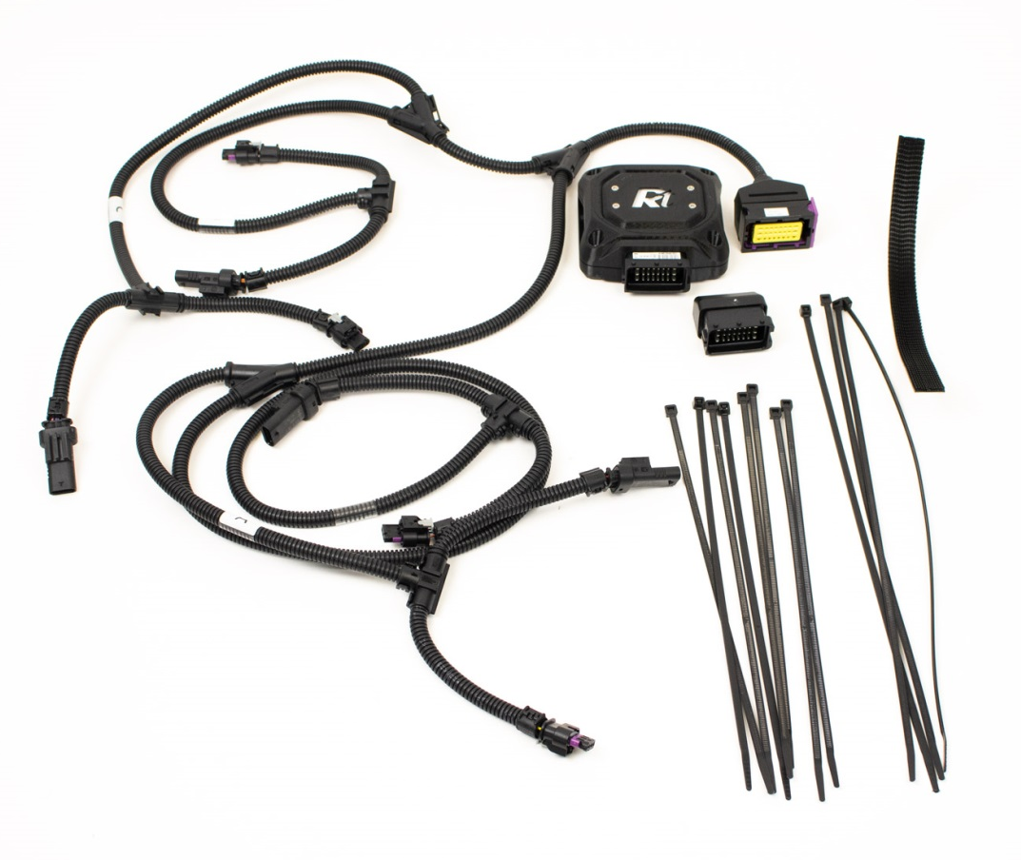
- Remove the engine cover.

Instructions RENNtech M176 M177 Tuning Unit
- Sensors A and B on both sides will be used for this installation as well as a camshaft position sensor, C.

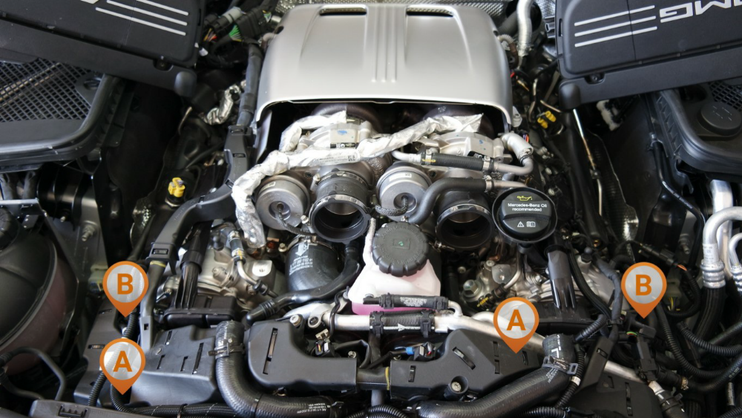
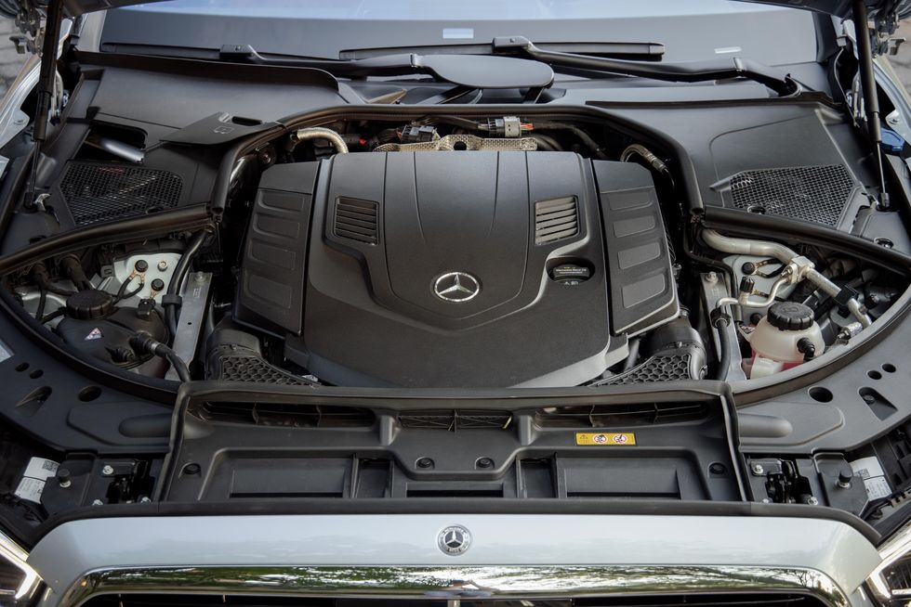
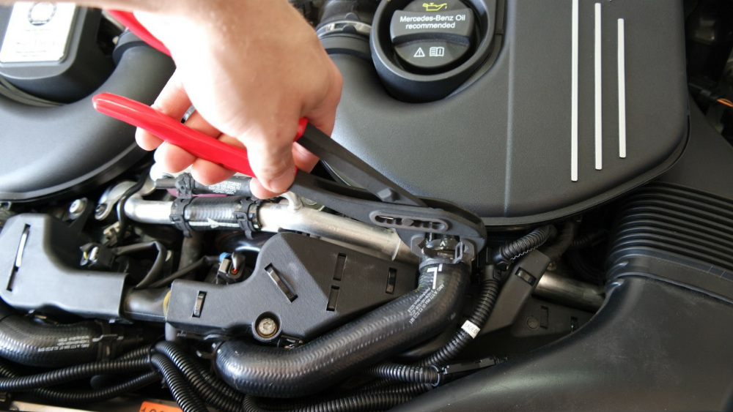
- Remove the fresh air inlet from the core support to the airbox.
- Loosen the couplers on the turbo inlets.
- Unplug the sensor in the rear of the airbox.
- Disconnect the charge air recirculation line. (Picture)
- Lift up on the airboxes to remove them and slide them out of the turbo couplers.
Instructions RENNtech M176 M177 Tuning Unit

- Make sure the car has gone fully to sleep. (the gauge cluster and all lights turn off) Unplug connector A from the charge air cooler on the left side (see detail photo). Connector A is the pressure sensor located under the wire loom that goes across the front of the motor.
- Connect the corresponding connector on the RENNtech harness to the sensor. Then plug the factory connector into the receptacle on the RENNtech harness.

Instructions RENNtech M176 M177 Tuning Unit

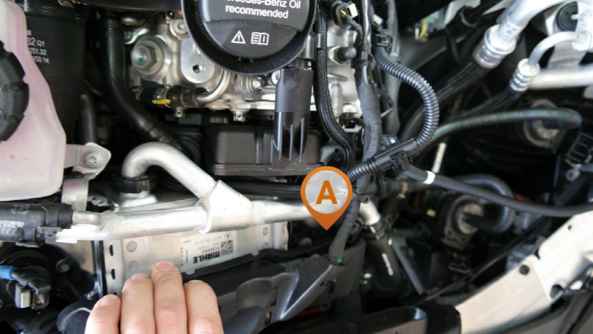
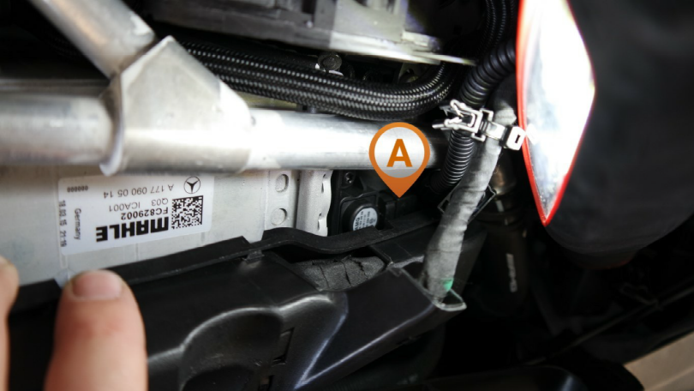
- Connector B is the manifold pressure sensor located on the intake manifold, just after the throttle body.
- Unplug connector B from the manifold pressure sensor and connect the corresponding connector on the RENNtech harness to the sensor. Then plug the factory connector into the receptacle on the RENNtech harness.
Instructions RENNtech M176 M177 Tuning Unit

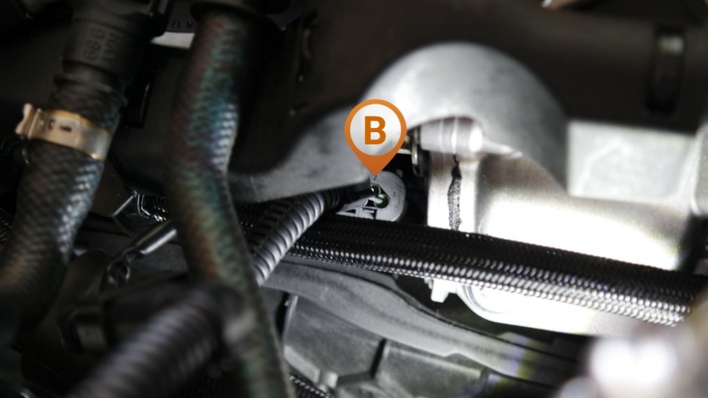
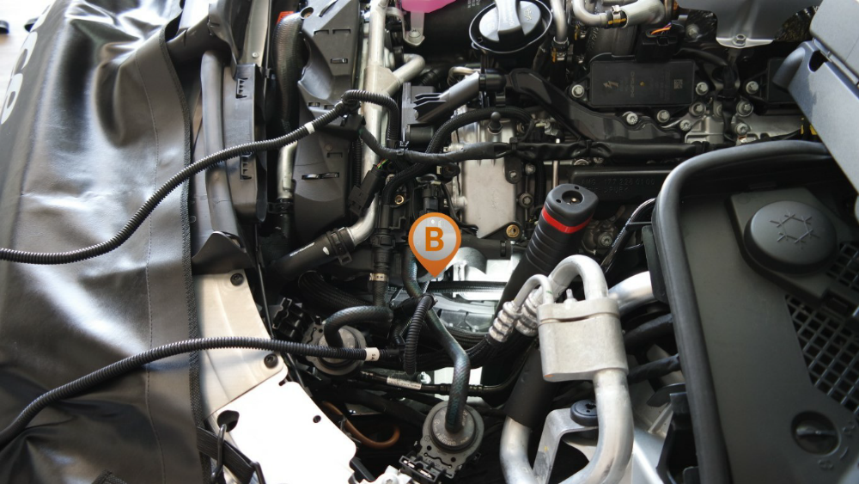

- There will be another pair of connectors, A and B, that correspond to another boost pressure sensor and manifold pressure sensor on the right side of the vehicle. Connect those to the RENNtech harness as well.
- Connector C can be used on any of the camshaft position sensors. Some are definitely easier to get to than others.
- Unplug connector C from the camshaft position sensor and connect the corresponding connector on the RENNtech harness to the sensor. Then plug the factory connector into the receptacle on the RENNtech harness.
Instructions RENNtech M176 M177 Tuning Unit

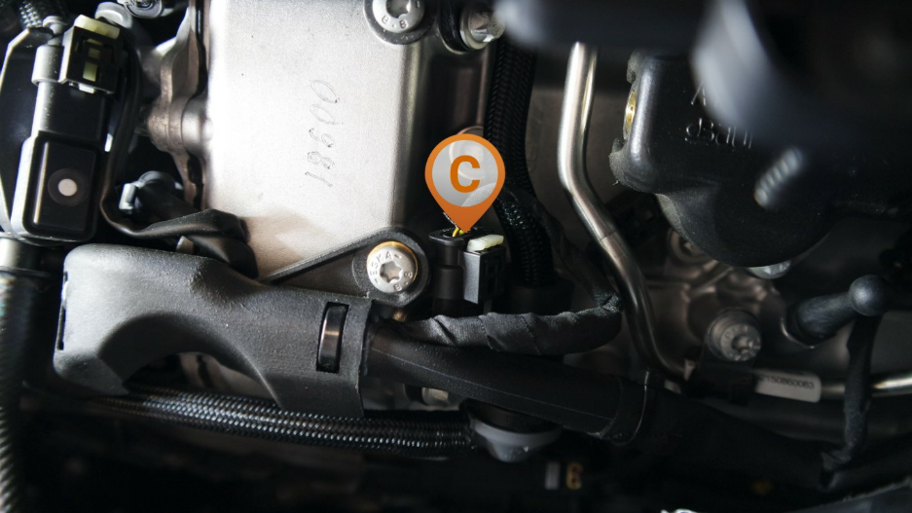

Instructions RENNtech M176 M177 Tuning Unit

- After the 10 connections on the RENNtech harness have been made, connect the RENNtech Module and locate it in the engine bay.
- The RENNtech Module location should be away from sources of heat and vibration. It should also be dry.
- Zip-ties or the included 3M Velcro should be used to fasten the RENNtech Module in place.
- Reinstall the airbox components ECU and loom.
- Start the vehicle and ensure proper operation.
- The bypass plug may be used to easily turn the vehicle back to stock.

NOTE: USE OF PREMIUM QUALITY FUEL IS A REQUIREMENT FOR THIS PRODUCT

Office Hours
Mon-Fri: 8:30AM-5:30PM EST
Sat-Sun: By appointment only


7825 SW Ellipse Way
Stuart, FL 34997
Tel: 561.845.7888
Fax: 561.845.6777

info@renntechmercedes.com
www.renntechmercedes.com

Subject to change at any time without prior notice.
© 2017 by RENNtech Inc.

