I hope I havent missed anything here as memory is a bit rusty from when I did this

Now my vehicle previously had Audio 10 (Option 756) installed, at some point in the cars life it was removed and butchered to add a crappy aftermarket head unit. I had 3x plugs with 2x 8 and 1x 10 pin.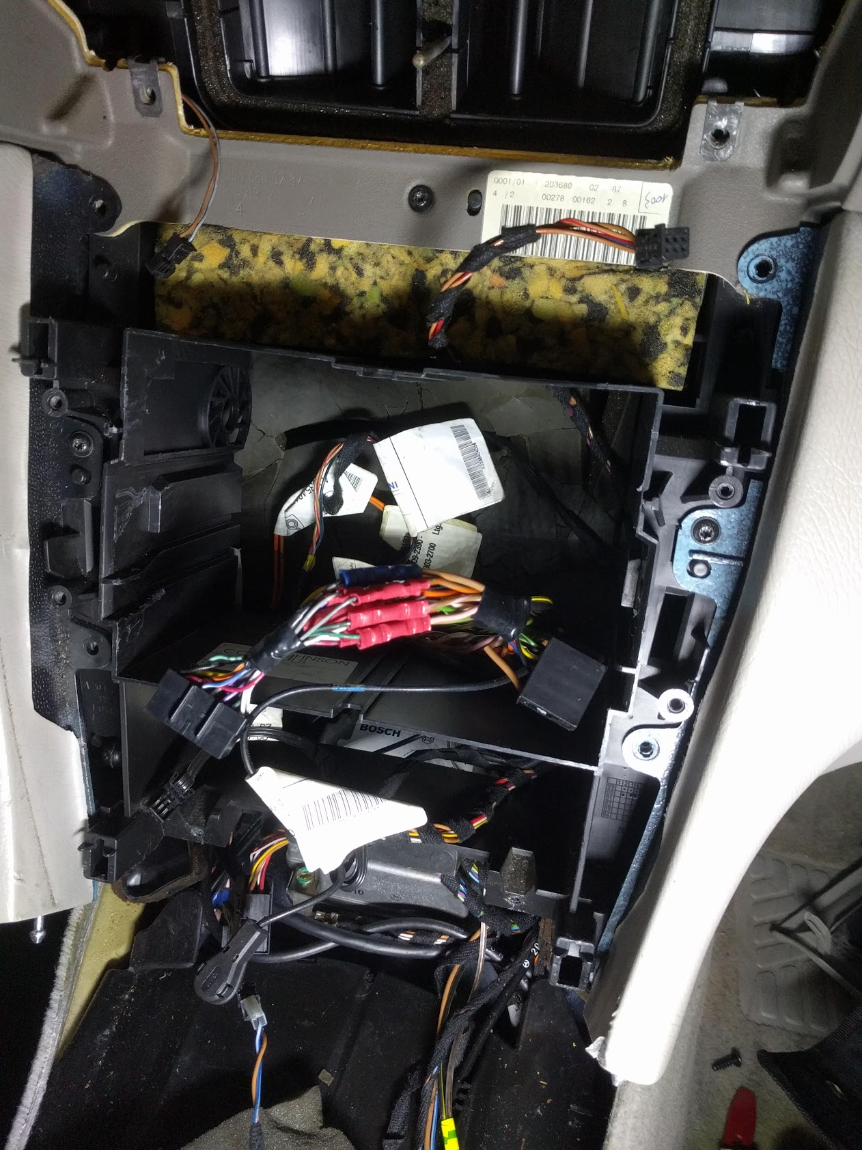
Heres the audio pin pinouts etc for reference and an image of the rear of one (pics from the web)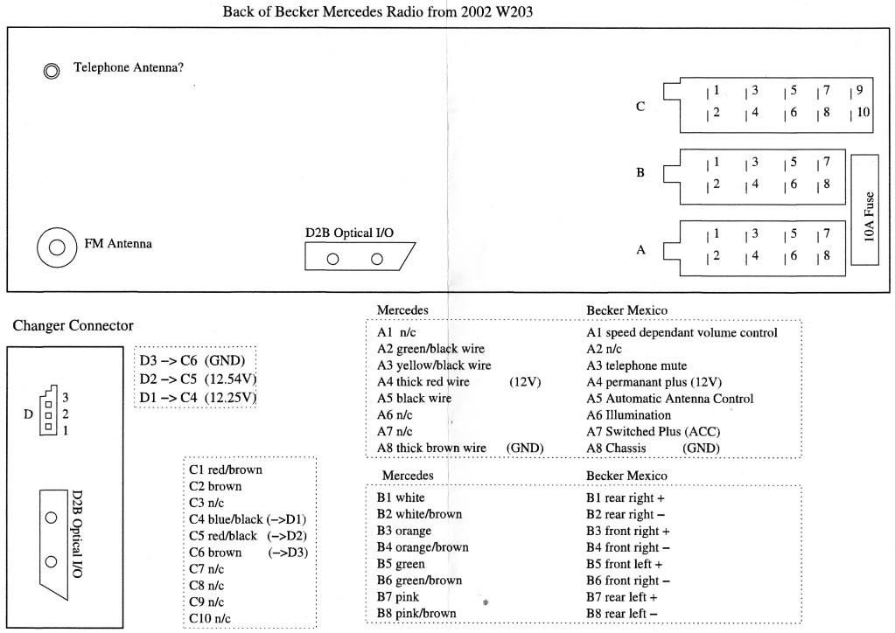.
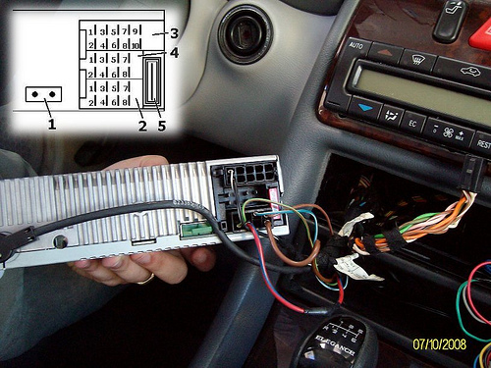
Heres the 3x rear plugs: One set of 8x controls all the speakers, another 8x is for power etc, the 10x only has 3x wires in it which I spliced into for the steering wheel remotes. 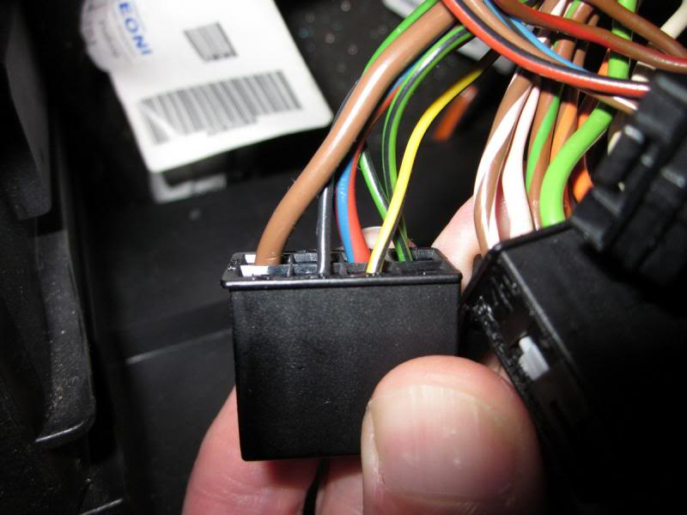
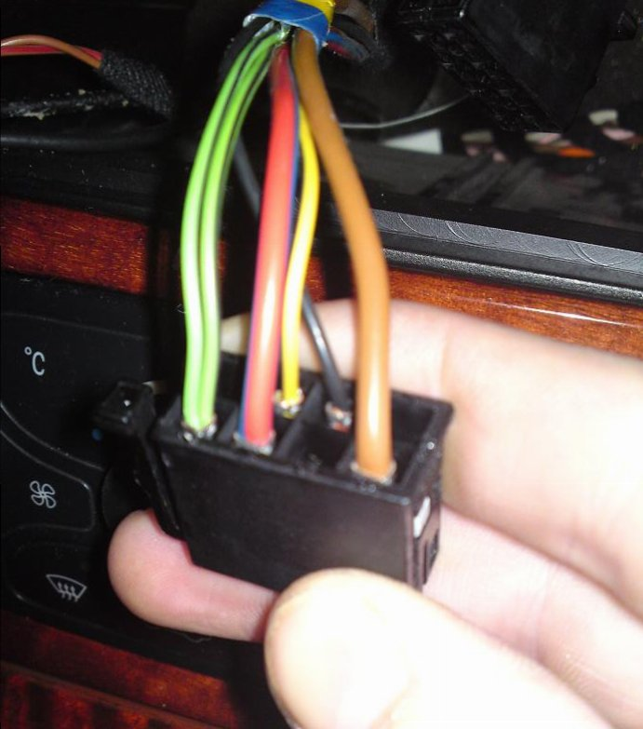
I tapped into the cigar light for illumination dimming splicing the head unit wire into yellow/black on the cigarette loom.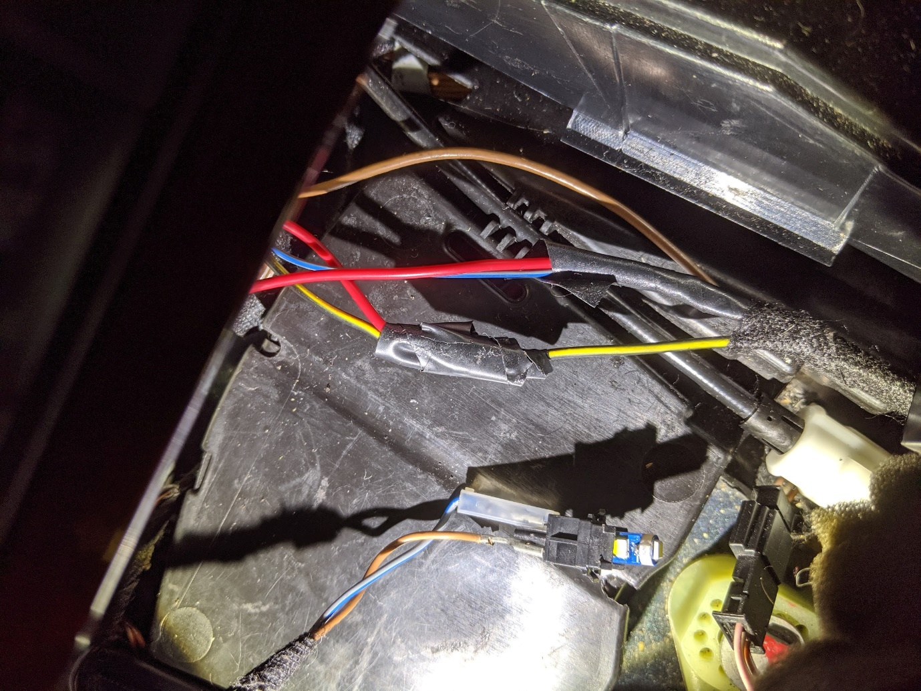
For the remotes I spliced the 2x wires from the Axxess ASWC-1 into the 10 pin Mercedes harness (which only has 3x wires within it) as follows: Pink-> Brown/Red, Blue/Pink-> Brown