https://mbworld.org/forums/c-class-w205/603704-official-wind-noice-service-bulletin-14.html

Official wind noice service bulletin
"24.10.2015 10:01
© Copyright Daimler AG Seite 1/2
Wind-, bzw. Umströmungsgeräusche im Bereich der Türen
Themen-Nummer GI72.10-P-061763
Version 3
Konstruktionsgruppe 72.10 Vordertür
Stand 23.10.2015
Gültigkeit TYP 205
Änderungsgrund Hinweis entfernt.
Beanstandung:
Wind-, bzw. Umströmungsgeräusche im Bereich der Türen.
Check the front door fitment and alignment; especially the transition of the front doors to the A pillar (see pic 1). Adjust door as required.
2. Check the outer panel of the mirror to ensure it is seated properly (see pic.2) (i.e. fitment is parallel with the door frame).
3. Check the sealant ridge for kinks along the arrows indicated in pic.3.
4. Trim a 30mm foam piece and fit it to the kerb-side trim piece on the front left and right. Refer to circled area in pic 3 and also pic 4.
5. Perform a test drive. Should noise signature not be changed, continue onto step 6.
6. Using a suitable adhesive tape, seal the gaps in the area of the front doors, windscreen, bonnet as indicated in pic.5, pic.6, pic7. Perform another test drive.
7. Should there be no change to the noise: Exchange the front side windows with Code 851 (Accoustic packet).

The LI you want applied is LI72.10-P-062500. It's pretty involved but ultimately will include installation of acoustic glass and insulating material.

So, they've put in the acoustic glasses for me today as well, I was the first to receive them in my town.
It did get better, you can't hear it as clearly from the front windows anymore, but its still there.
BUT, now both me and the MB tech agreed that we hear a lot of windnoise from the rear. From the rear glasses it sounds like.
I got my W205 9 days ago. Told them I'd noticed the wind noise when they let me test drive it for two days, and mentioned that a TSB had just come out in German. Made an appointment on Monday, after a lot of driving over the weekend confirmed the noise in various situations.
Brought it in today. They went through the TSB steps (lots and lots of tape) and ordered the acoustic glass at the end. It was as straightforward as that. No complaints, no eye rolls, no shoulder shrugs

My service advisor in Michigan called me on December 28th to let me know that my acoustic glass had arrived. It was installed on the 30th. Covered by the factory warranty, without the slightest hint of pushback. I've noticed an improvement, although it definitely seems to be a matter of obscuring the outside noise, rather than eliminating the cause of the noise.

I got the both windows replaced by mercedes (took a week) and finally got the car back yesterday and it is noticeably quieter. I was in a 2016 c300 the whole time with the regular glass and i noticed the difference as soon as i hopped in my c400.

Yes, X1 is the marking for acoustic glass.
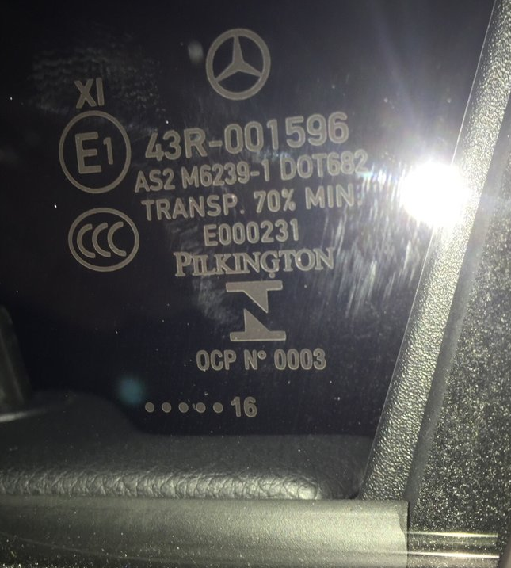
So after owning my car for 5 months, I finally brought it in for the wind noise. At highway speeds, if there's no wind it can be tolerable. But any hint of a crosswind and the noise is just too much. My local dealership initially gave me some pushback but after taking a test drive with the mechanic, they finally went ahead and said they found some Service Bulletins that they can apply.
UPDATE:
Got my car back today and couldn't be happier. Acoustic glass installed on both driver and passenger side front doors along with felt. Initial impressions...absolutely worth the battle with the dealership.

