Instructions:
This will make the seat only operate when the key is on, not when off. Don’t do this if you want the seat to slide back when you turn off your car.
This will prevent the battery drain that a bad seat module in the W203 causes. It is easier and cheaper than a new module.
NOTE: This will work on all W203, BUT you may have different colors. Please check the voltage before splicing.
Tools you need:
(2) - Wire Splicers (or soldering kit)
Pliers to crimp wire splicers
Electrical Tape
Scissors for electrical tape
Wire Cutter
1) Look under your seat and find the connector with the 3 wires (center of picture below). Pinch and pull it out.
(BROWN), (RED WITH GREEN OR YELLOW STRIPE), (BLACK WITH WHITE STRIPE) and disconnect it.
The Brown Is Ground
The Red Is +Positive Constant 12v (with key off)
The Black is +Positive 12v only when key is turned to on position
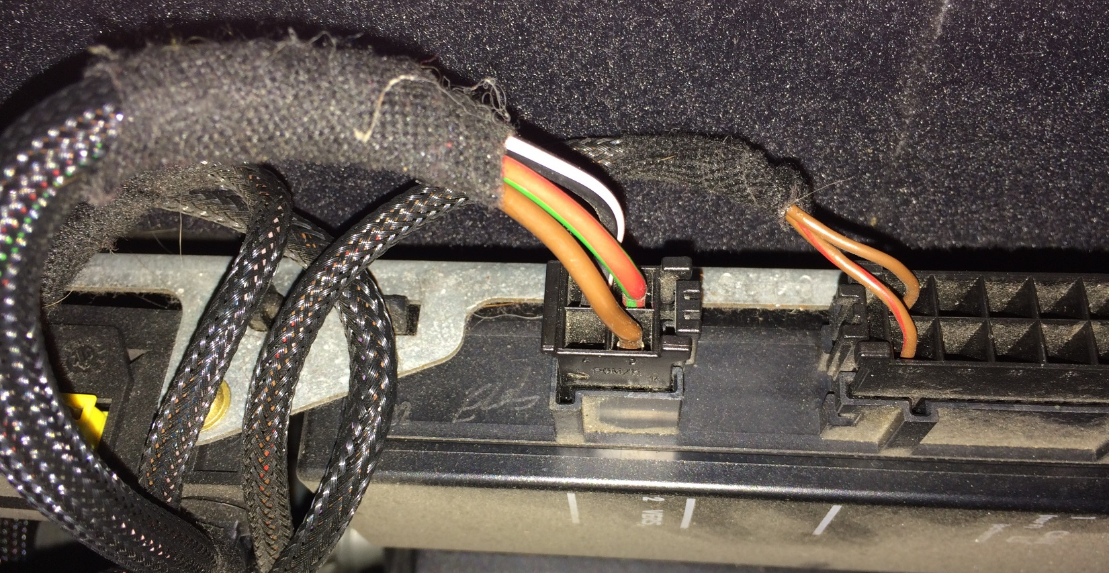

2) Remove or slide back some of the electrical tape on the wire loom.
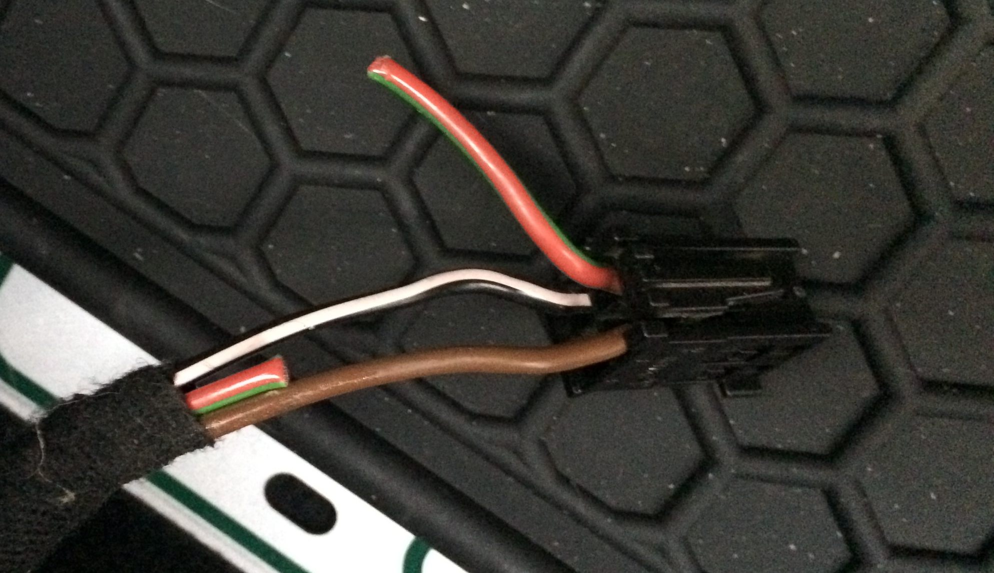
3) Cut the Red wire and Splice it with the Black wire. I removed ¼” of red wire to give more room. The black wire will provide power to the red wire only when the key is turned on.
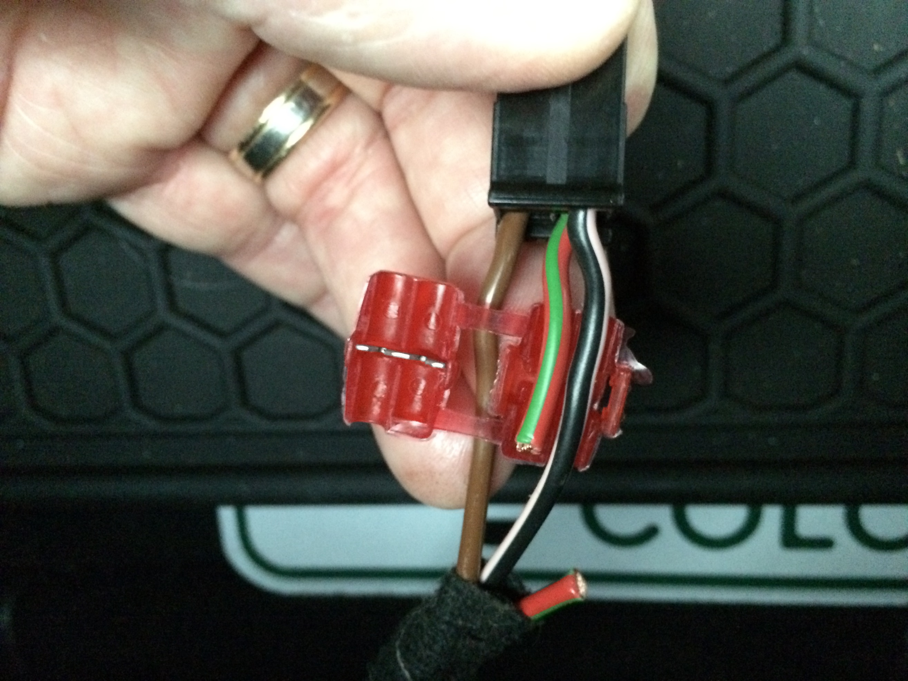
4) Make sure you tape off the RED 12v coming in from the left above !!!
5) Wrap everything up with electrical tape, plug it back in, and you’re done. Now test. Seat should only operate when the key is on, not when off.

