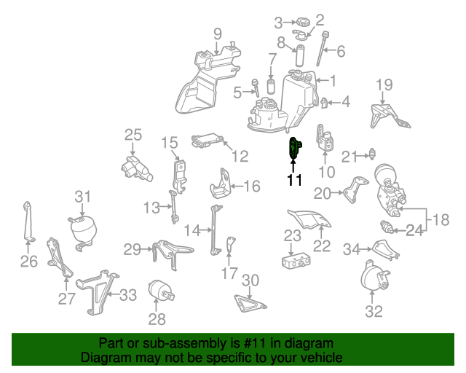

Acceleration Sensor (Horizontal)- Mercedes-Benz (000-905-70-02) $59.50 (oemvehicleparts.com)

