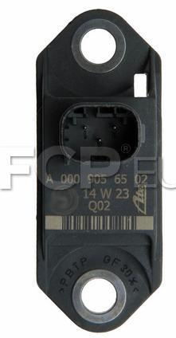
2009 Mercedes-Benz CL63 AMG (ESP Speed Sensor) Position: Rear (Vertical), Chassis Range: To A023465. (FCP EURO) $181.99
OE NUMBERS
0009056502, 0005422118, 0005422218, 0015428018, 0025426918, 0045423518, 004542351805, 004542351828
Acceleration Sensor Failure Symptoms
- Stalling
- Rough idle
- Missfires

