Click “Image”

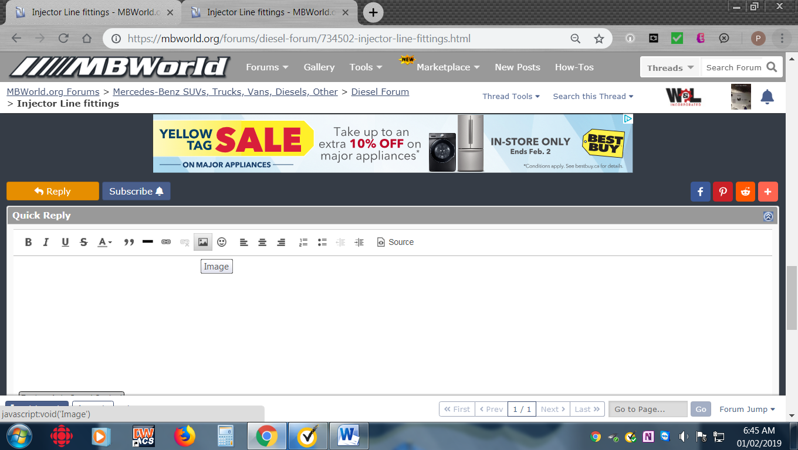

Click browse your device if getting the pics from your computer

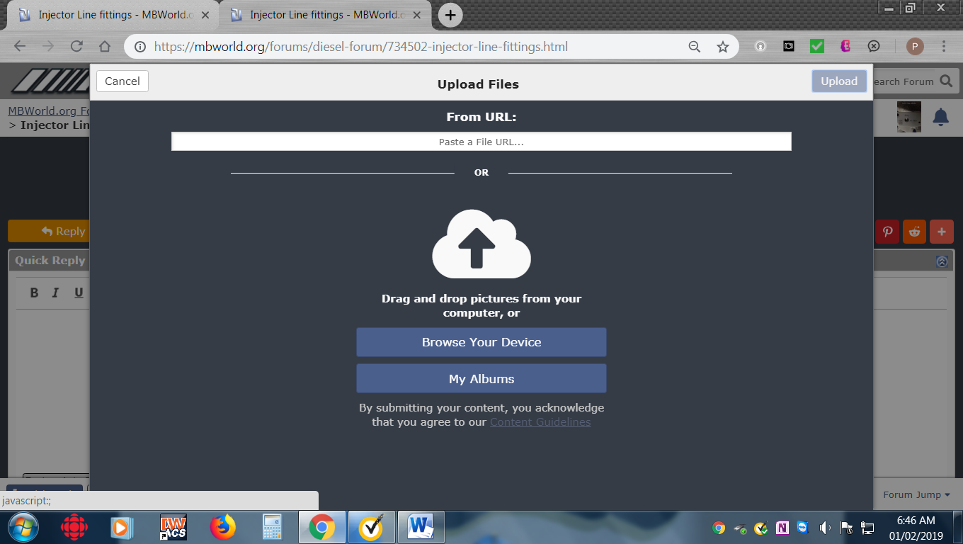

Choose the pic you want to post

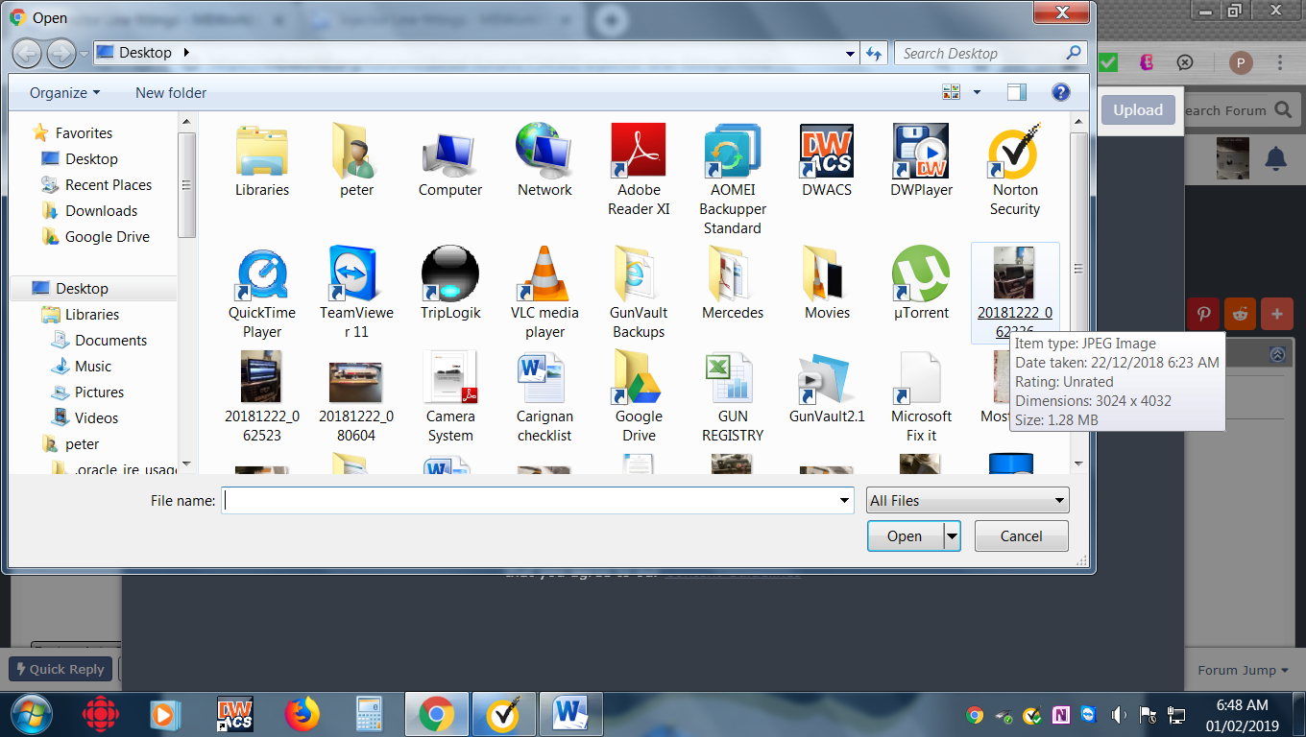

Wait ‘till it downloads and shows this

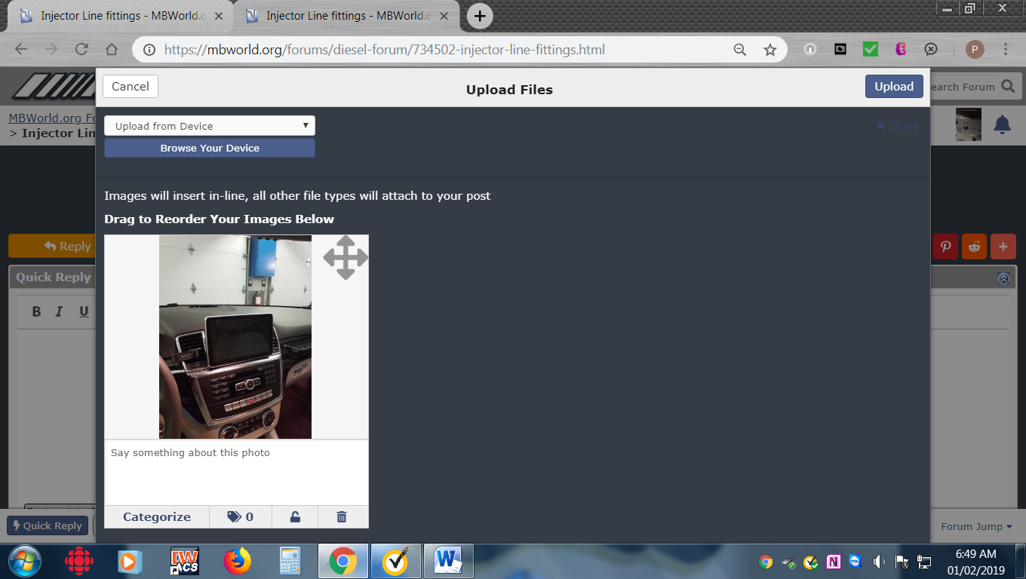

Then click upload at top right corner and voila

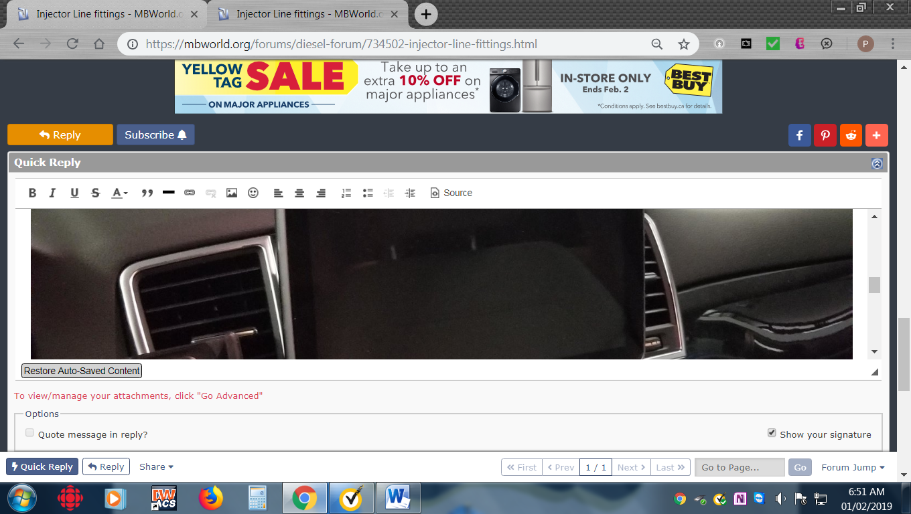

Add your narrative and Bob’s your uncle. Hope this helps!

