Disconnect battery before starting !!
Materials / tools #20 Torx bit and electric driver, trim removal tool kit, tiny metal screwdriver or picks for plugs on harnesses. Pry up at the arrows…Same on E350. Note my shifter has the wood knob.
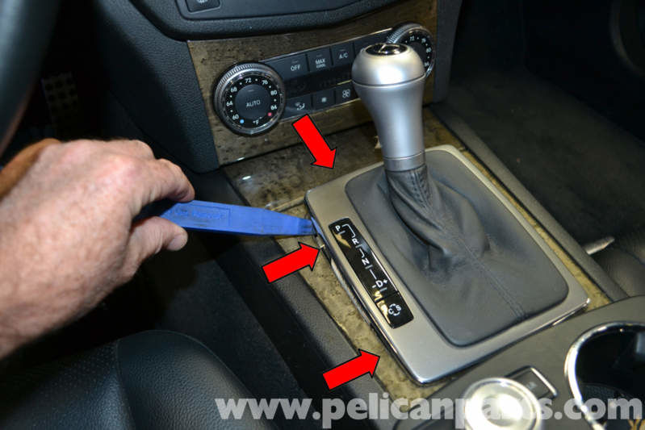

Disconnect harnesses. Same on E350.
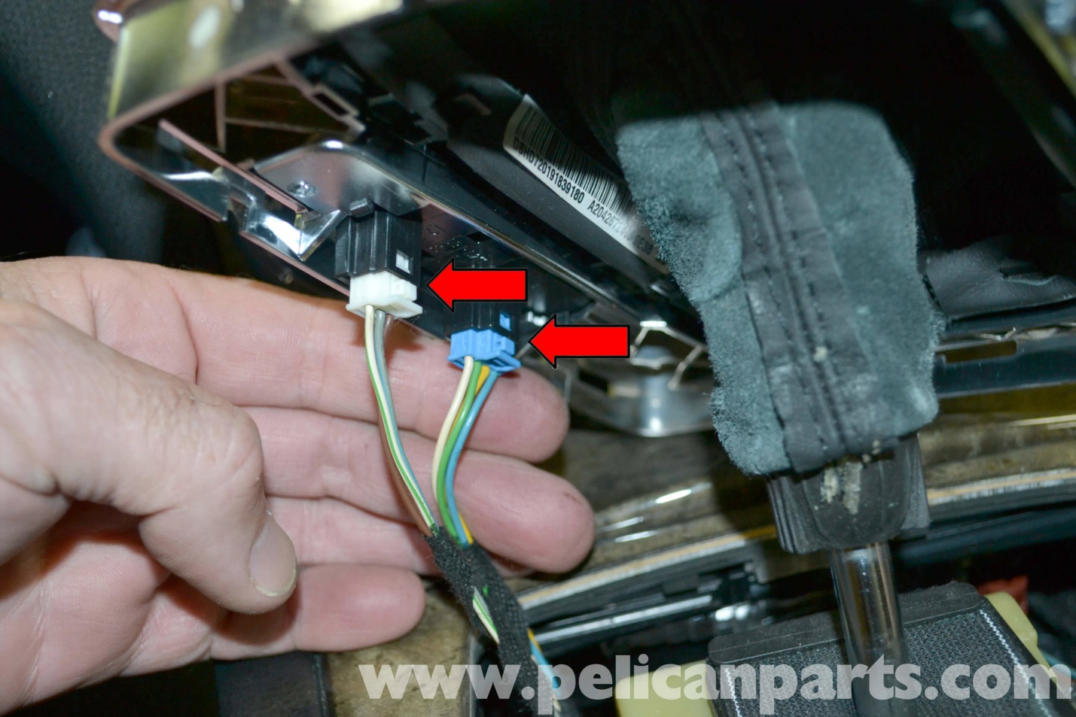

Turn knurled knob counter clockwise. Same on E350
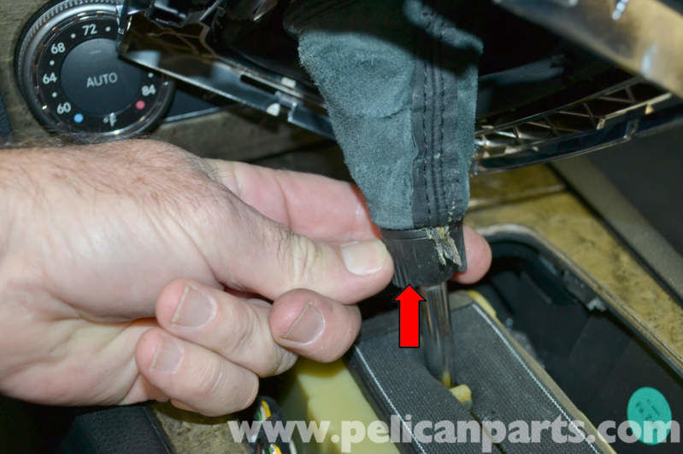

Pull knob straight up to remove along with leather gaiter. Same on E350
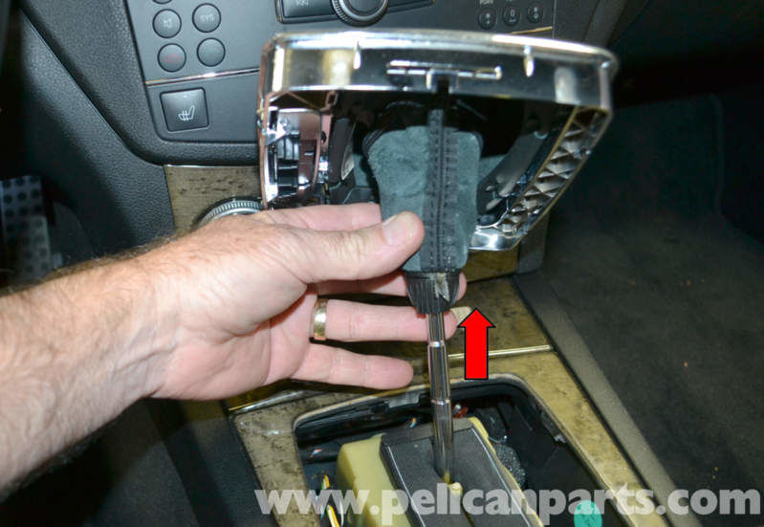

Pry up on surround carefully at front left edge and then front right edge. Same on E350
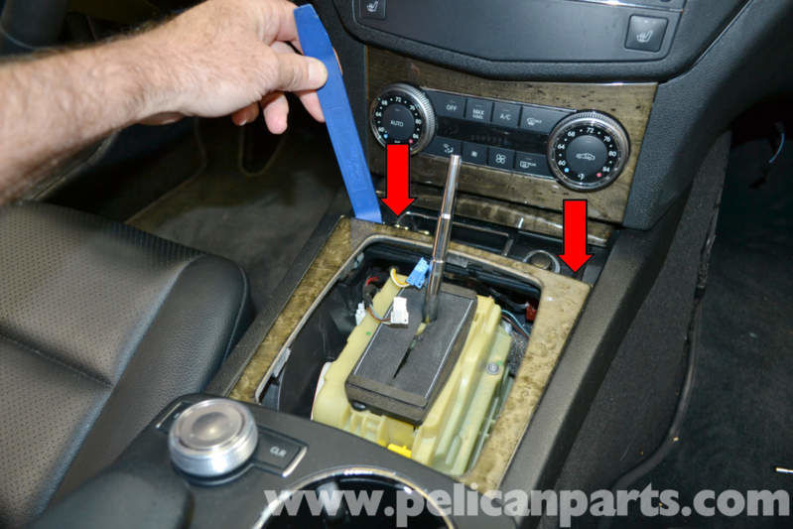

View of clips same on E350
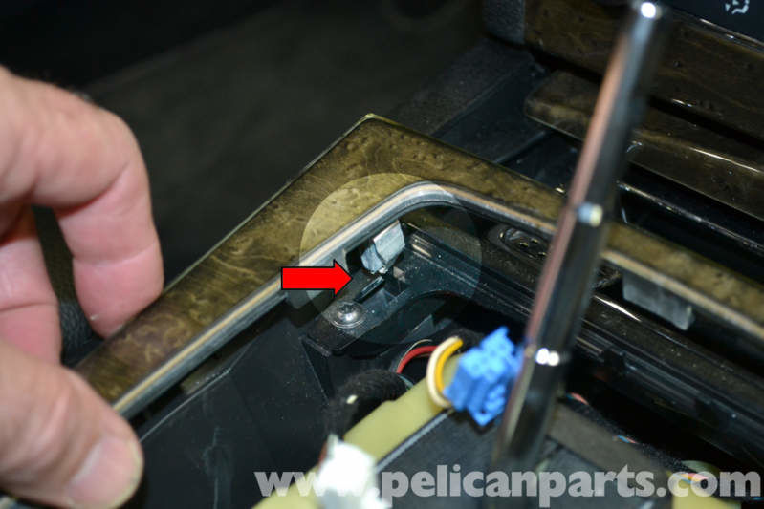

This might not be right for the E350 A207 convertible. There is a screw in the front cup holder, though. Pull up the rubber cup liner to access the screw. Remove that one screw …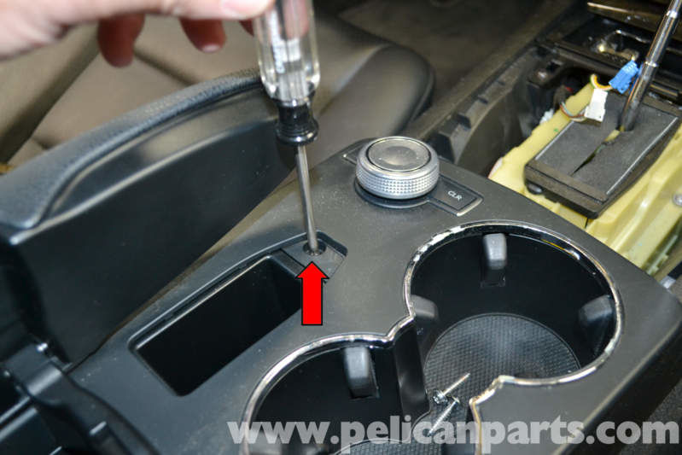

Removing the trim surround gives access to the 2 screws just at the front of the middle section of the console. Remove those 2 …
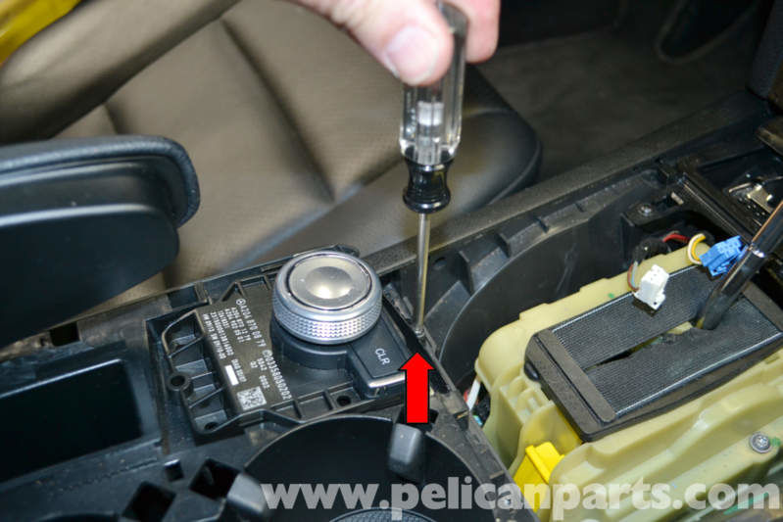
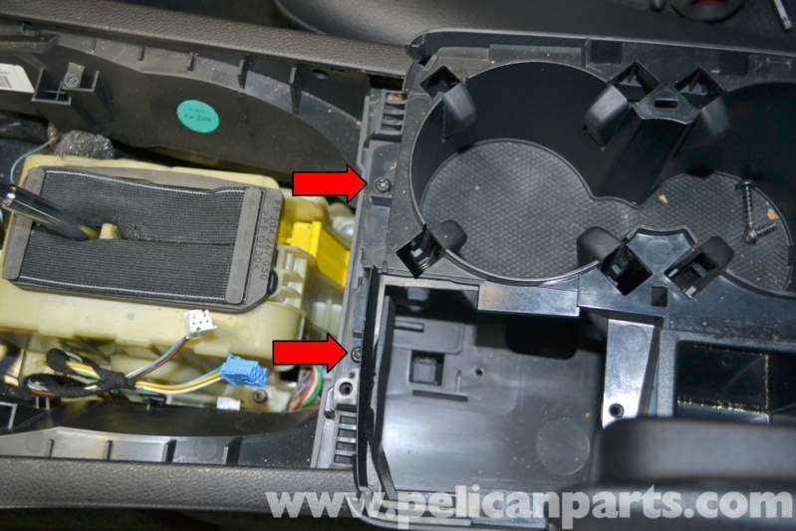
Not sure if this is the same on an E350 cabriolet but disconnect the harness along side the shifter….use a pick tool
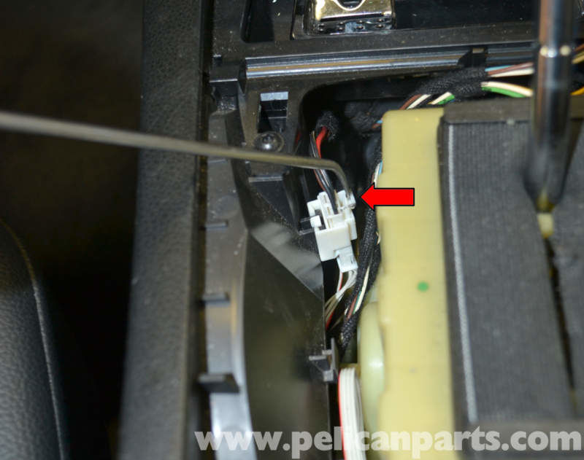

Pull up firmly on rear vent. May be hard to remove. Design not quite the same on E350 Cabriolet . be careful not to damage the vents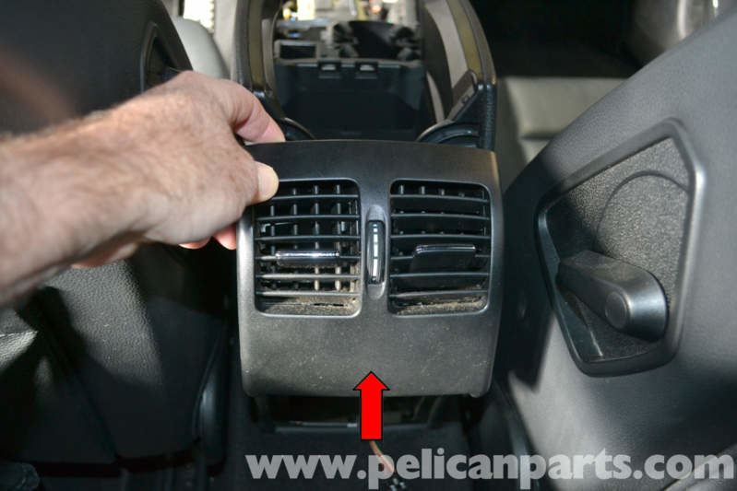

Remove 2 screws at the rear where the vents were removed. Same on E350 Cabriolet
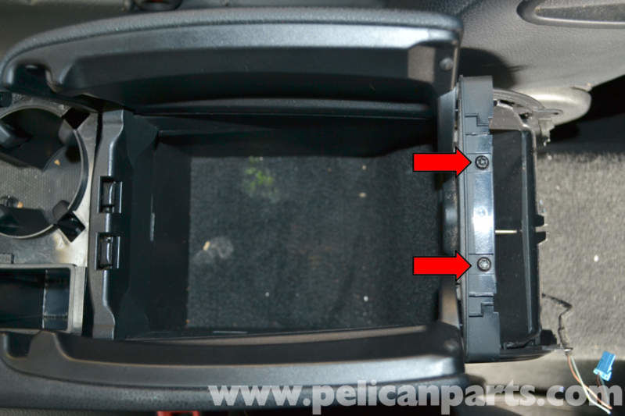

Start at the front and work back releasing the tabs and pulling up as you go, this removes the middle part of the console……note the E350 A207 console looks different as it has a separate small cover for the top controls….
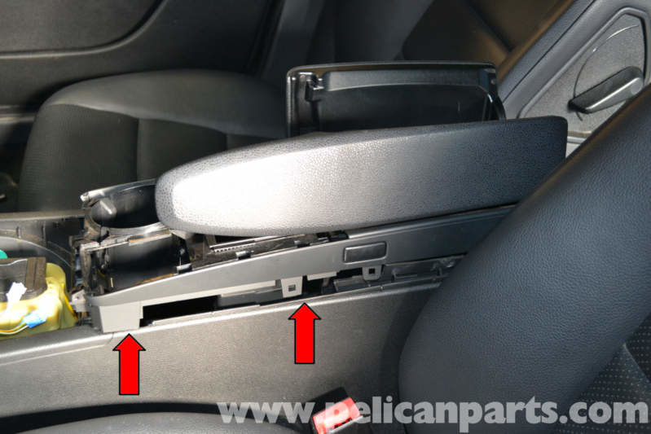

Not exactly the same for 2012 E350 Cabriolet but E350 A207 cabriolet center console portion is still all one piece. Check to make sure any harnesses that may need unplugging are unplugged before going further !! May need to keep in place car due to length of harnesses….
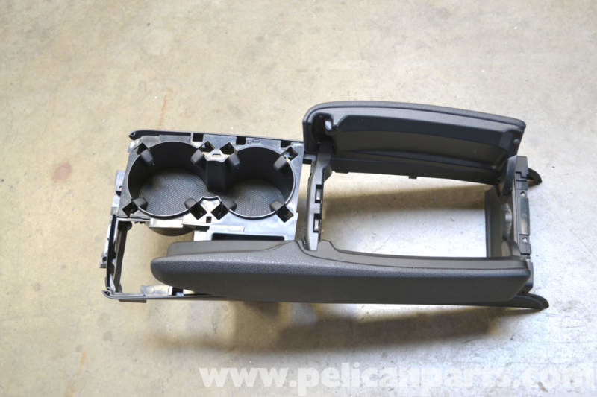
Turn it over and unscrew the 3 screws holding the small convertible control box in place. Will need to unplug the controls and then use the removal tools to pop the whole small convertible control unit out.
Remove the 1 screw holding the controls from the old box, then install controls into the new box.
Re-install the one screw then reinstall the box into the console. Reinstall the 3 screws for the box , and plug the harness back in.
Check to make sure any other wiring harness connections are re-connected, then re-install the middle console into place in to the center console, snapping it in …..
Re-install the 2 screws at the back of the console, then slide the rear vents into place and snap down. Check to make sure the flaps all work properly before continuing.
Re-install the front 2 screws at the front of the middle console and the one screw in the cup holder
Re-connect the harness in the front by the shifter
Re-install the surround
Re-install the shifter knob and leather gaiter
Re-install the shifter surround
Re-connect battery
DONE !!!!

