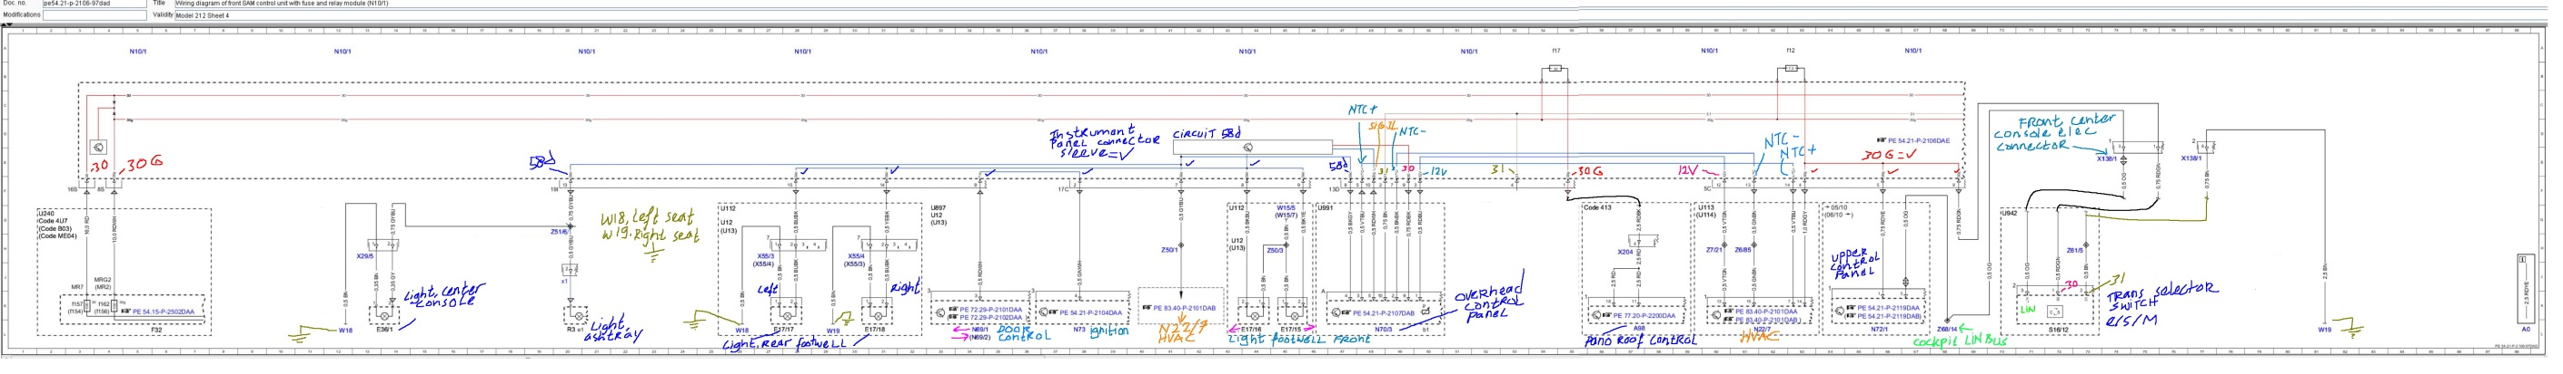

Before stripping down , N10/1 sheet 4 is below
