DIY – Remove the rear emblem that has camera (2020 GLC43 Coupe)
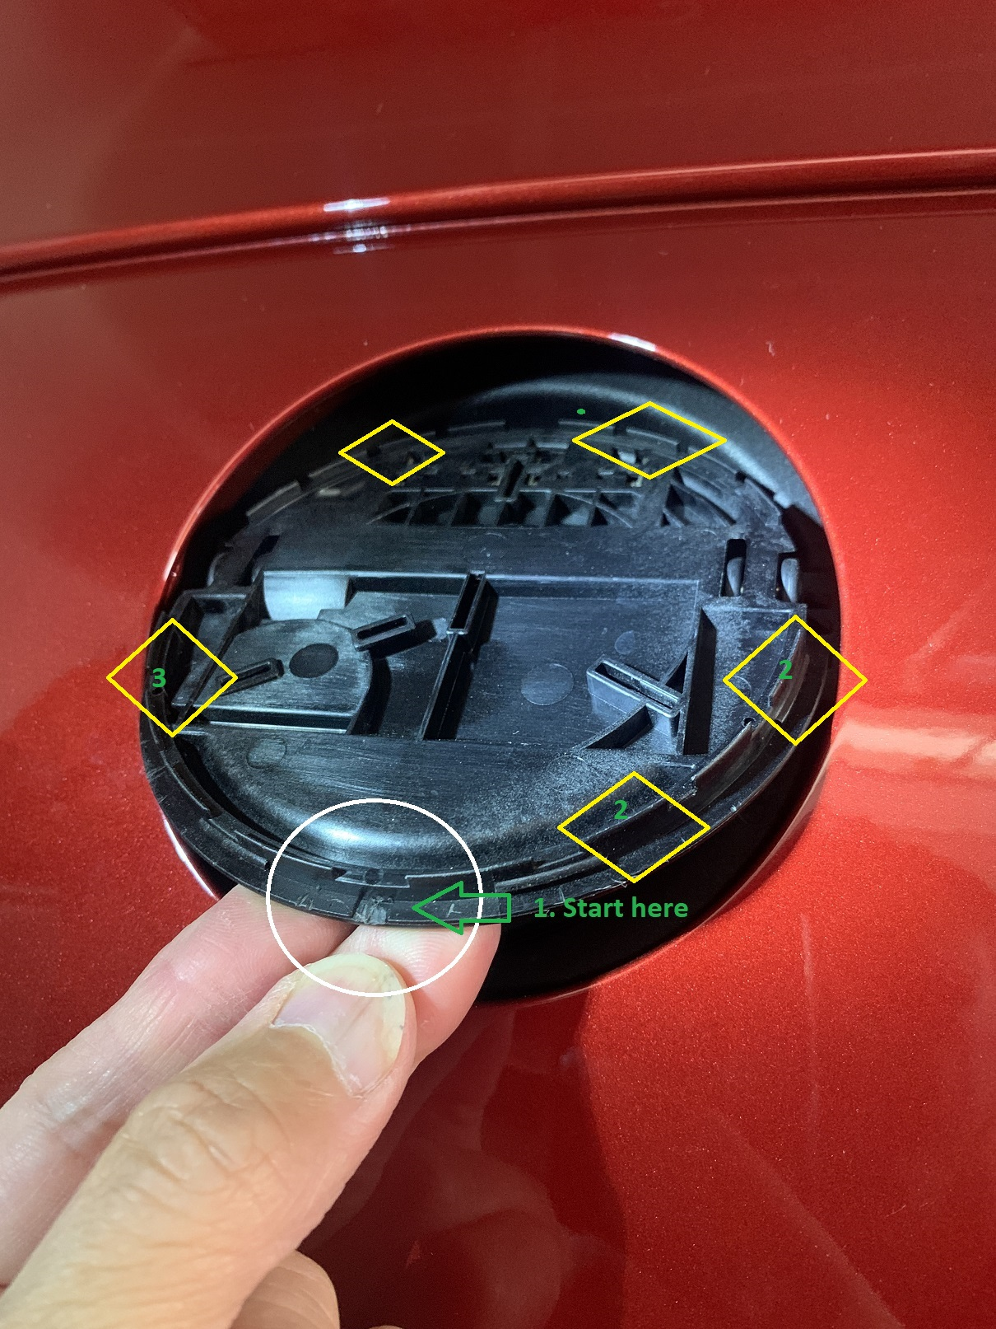

This is how I did it, do it at your own risk just be patient and careful.
- Car was locked and without the key near me, lifted the star as if I was to open the trunk at an angle and use a very small flat head screw driver, laid it flat like the piece (#1), and turned the head to 90 degree so the piece will pop up.
- I moved to position #2 and repeated last part of step 1 until that area pop.
- Then I moved to position 3 and repeat last part of step 1 again.
- At this point, half of the circle was already out, I returned the star back to normal position and held the star and wiggle it a bit until the top half of the star pop out.

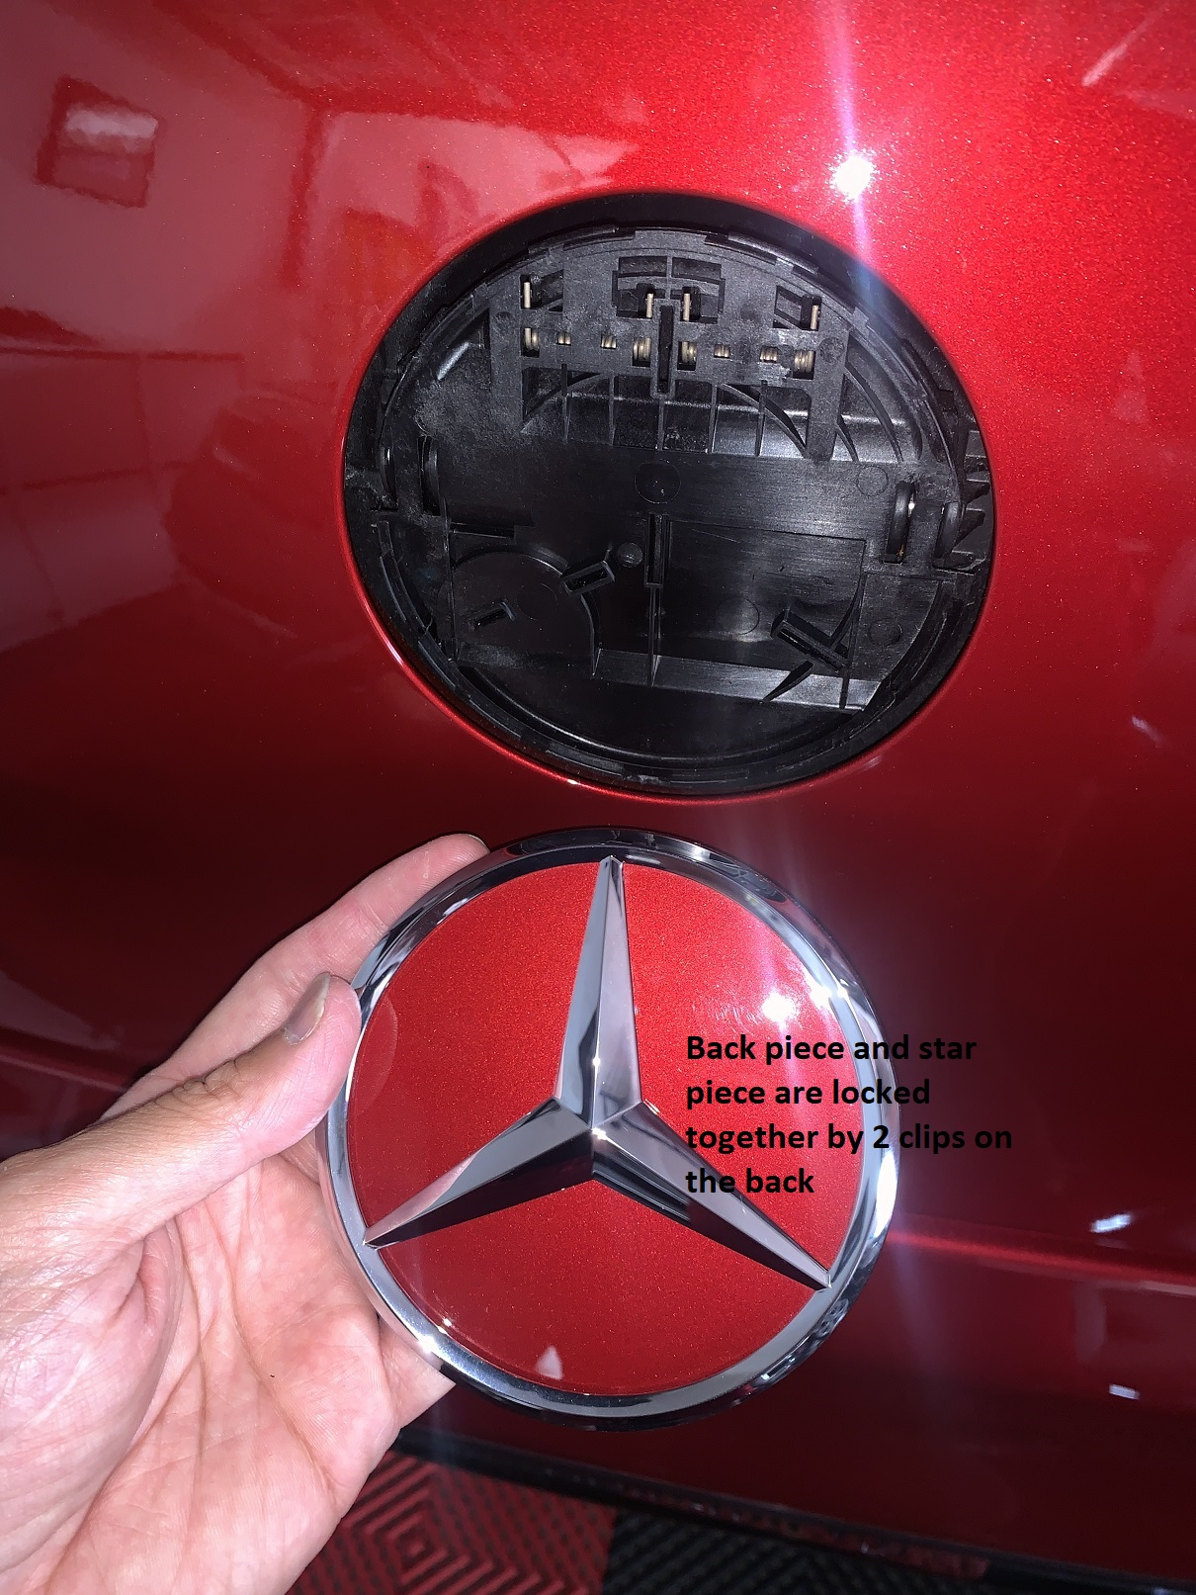

- This step is tricky; I did not figure out how to separate the 2 pieces (green circle below).
- From this point, you can wrap the area that you don’t want to paint or you can try to separate the 2 pieces without breaking them. I wrapped mine then painted it.
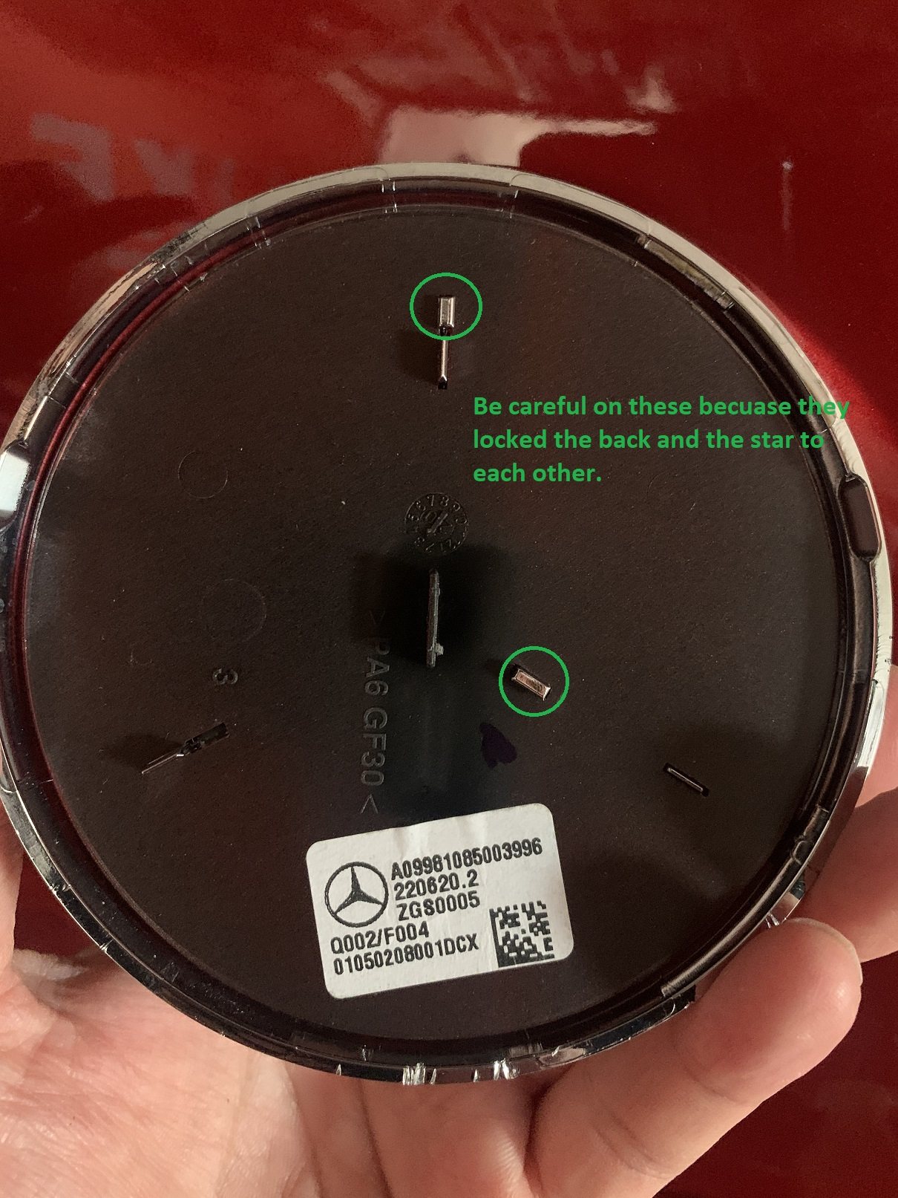
- Reinstalling it is easy, just gently snap the piece back in all around.
