AR15.12-P-2003GQ Remove/Install Ignition Coils
ENGINE 276 in MODEL 166, 251
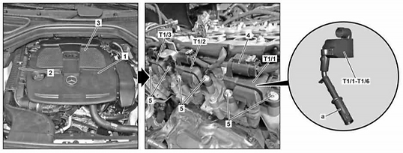
Shown on model 166.0 with engine 276.9
1 Front engine cover
2 Air filter housing
3 Resonance intake manifold
4 Connector
5 Screw/bolts
a Spark plug connector
T1/1Cylinder 1 ignition coil
T1/2Cylinder 2 ignition coil
T1/3Cylinder 3 ignition coil
T1/4Cylinder 4 ignition coil
T1/5Cylinder 5 ignition coil
T1/6Cylinder 6 ignition coil
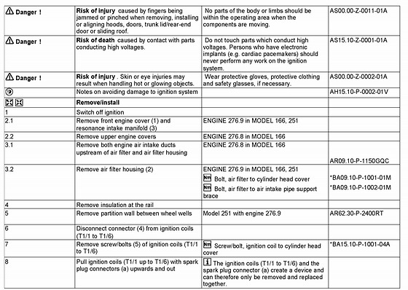

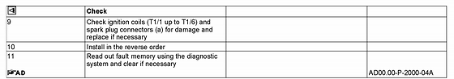

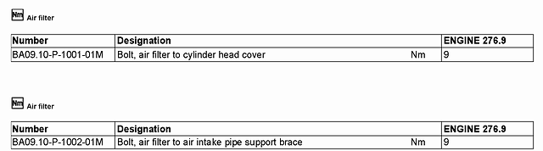

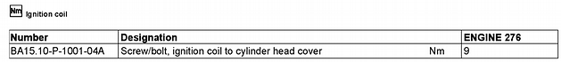
If you are satisfied with my answer, Please Rate my answer by clicking the rating button so I can get credit for my work. I’m not always going to be giving you good news, so please don't let this stand in the way of you accepting my answer. .it does not cost you more money and we will still be able to communicate, ,.please understand, i can not see, hear or touch the vehicle and only know what you tell me. Bonuses and positive feedback are appreciated.. if you are not satisfied with my answer, please do not leave bad feedback ,i will gladly opt out and let another expert handle the question. .if i have sent any diagrams, please print them. .sometimes you may need to right click the image [,then save picture as]to save it to your computer so you can open it with your picture program...Please ask if you need more help.

