Mercedes Benz ABC System Troubleshooting Guide

Sunday, August 24, 2014

ABC System
Welcome to my guide for the Mercedes Active Body Control (ABC) Suspension System.
In July of 2014, I purchased a used 2003 Mercedes SL500 with 80,000 miles on it. And within
days the infamous "ABC Drive Carefully" message started appearing on the dash. That was
my introduction to the ABC system. While my car was in the shop, I got the distinct impression
the dealer was grasping at straws trying to figure out what was wrong, so I figured I would educate
myself about this system to avoid the dealership throwing parts at the problem at my expense.
Afterwards I decided to share what I have learned since I have encountered a lot of confusion and
bad advice out there about how this system works and what to do to fix it when something goes
wrong. The online owner forums have been very helpful to me, and I figured I would give
something back to the community.
Troubleshooting Summary:
Here is a cheat sheet to help determine the cause of a problem and what action you should take. Or if you are having a repair shop do the work, this table can help you verify the shop has made the right diagnosis and is attacking the problem correctly.

Symptom | Cause | Action to Take
Any time "Drive Carefully" or "Visit Workshop" appears and it isn't related to a known issue you are dealing with. | The ABC control module has sensed something wrong and is warning you. Blue or white is a minor warning, and red is a severe warning and usually indicates the system has shutdown.  If the message only appears briefly, the problem was likely a momentary drop in system pressure. The system recovered and is working normally again.  If the message stays on the dash, something has gone wrong with the system. | If the message stays on the dash, and this is the first time you've seen this error message in a while, pull the car over immediately and shut it off.  Check the fluid levels and make sure the reservoir is not empty or extremely low. If so, do not start the car again until you have added more fluid and restored normal pump operation.  If you attempt to drive the car without adequate fluid, the pump will be destroyed in very quick order (a $2,500 repair), while shedding metal debris into the system that will damage other components as well.  It is NOT worth trying to drive the rest of the way home!!!! Even if you do make it home, you will have drastically shortened the remaining life of the pump.  If the problem was not fluid level or pump related, you can continue to drive the car while you sort out what the problem is.
"Drive Carefully" appears for a few seconds when hitting a bump or dip in the road.  This may or may not be accompanied by fluid overflowing from the reservoir. | One or more of the accumulators has failed and is no longer supplying pressure to help fill the struts when needed. | Start paying close attention to the fluid level in the reservoir. If it starts to drop and the messages start coming more frequently, then you have blown an accumulator.  Pull and inspect the front and rear axle accumulators - each are part number 2203270115 (the large ones). It's likely both are blown. Replace as necessary.  The life expectancy of these accumulators is around 10 years or so. So if one accumulator has worn out, the other accumulators in the system are likely to be in similar condition and will fail soon. Given these accumulators only cost about $150 each, you should seriously consider just replacing them all as a preventative maintenance investment.
One or more corners of the car sags or lowers when parked.  One or more corners of the car raise shortly after the car is shut off. | Per MB, it is normal for the car to sag after a couple of weeks given the design of the valve blocks. If a corner sags after only a few days, then you should be concerned.  Possibilities are:  1) The strut may have developed a leak (less likely)  2) The valve block is not making a good seal, allowing fluid to escape out of the strut and return to the reservoir, (most likely). Possible causes are:  a) Gunk has built up in the valve block (in the shutoff valve in particular) (less likely)  b) The o-rings in the valve have deteriorated or are worn out. (most likely) | If the strut is visibly leaking, then it must be replaced. Also be careful not to let the ABC fluid levels get too low. Start carrying extra ABC fluid in the trunk until fixed.  If the valve block is not holding a good seal, then the first action is to change the ABC fluid filter, perform a procedure called a "rodeo" that exercises the system, and then replace the filter again. This will sometimes clear up the problem, at least temporarily. This will cost around $300. If the fluid is dark, you should strongly consider having it flushed, which will cost another $500.  If the filtering fails, there are DIY guides on the internet showing how to pull these blocks and rebuild them. Labor cost is around $1500 and parts costs is negligible. Although not a MB approved procedure, it is usually successful.  You last option is to have the valve block replaced. This will cost around $3,000, or around $1,500 if DIY.  You can also find rebuilt valve blocks on ebay for a few hundred dollars.
"Drive Carefully" or "Visit Workshop" appears on the dash every time you start the car and stays on. It never goes away | There is a malfunction in the ABC system somewhere. The ABC system noticed a problem when starting up and has disabled itself, locking the struts in their current position. This may result in what many people describe as a "tuna boat" ride (very bouncy).  Possibilities are:  - A loose connection to a sensor  - A sensor has failed  - The pump has failed  - The system has a fluid leak and the fluid level in the reservoir is extremely low, preventing the system from getting up to operating pressure. | Check the fluid levels in the reservoir. If empty do not attempt to start or drive the car. If you run the pump dry it will be ruined...a $2,500 repair! Go the parts store for a quart of "Pentosin CHF 11S" fluid and fill to the upper mark before starting the engine.  If in fact the pump was run dry, the pump may require priming to get operational again. This is done by pressurizing the reservoir to help the pump get the fluid moving again.  Check the underside of the car for any signs of fluid leak.  If the system is unable to hold it's fluid long enough for a drive to the workshop, then have the car towed.  You will need a scanner capable of accessing the ABC control module through the OBDC port to get the ABC related codes, see sensor values, and run diagnostic routines.
"Drive Carefully" or "Visit Workshop" comes on the dash and stays. Stopping and starting the car sometimes resets things back to normal for a while. | Possibilities are:  - The pump is weak, resulting in inconsistent performance. Sometimes the ABC system reaches operating pressure, sometimes not.  - A strut travel sensor or ride height sensor may be going bad. Some motion from driving gets it working again. | You will need a scanner capable of accessing the ABC control module through the OBDC port to get the ABC related codes, see sensor values, and run diagnostic routines.  If it is the pump, low pressure error codes will have been logged.  Confirm the pump by monitoring pressure during a rodeo. If it can make it through the rodeo without the pressure dropping below 100 bars, the pump is fine.  A sensor problem will usually have error codes logged that point to the offending sensor.
You can hear a hum or whine under 2000 rpm. Is present both in gear and out of gear. | The pulsation dampener has worn out. | There are lots of pumps and other non-ABC components that produce noises like this on these vehicles, so try to located the source of the noise using a stethoscope or long screwdriver.  The ABC component most likely to cause this noise is the pulsation dampener. The location varies by model and year. On the R230 it is located in the front-left wheel well. On the W215 it is attached to the undercarriage near the transmission.  On later models with the updated ABC system (2007+), the pulsation dampener is on the ABC pump.  Replace the dampener. Cost is around $175 and is a relatively simple DIY project. Or around $600-800 if you have a shop do it.
You hear a hissing or whistling coming from the valve blocks  On R230, they are located in the front left wheel well on the side nearest bumper, and the rear wheel well on the side nearest driver's door.  On the W215, they are located in the front left wheel well on the side nearest bumper, and on the rear underside of the car. Follow the line from the strut to find it. | Air is trapped in the line between the strut and the valve block. | Correcting the problem involves lifting the vehicle or jacking up the vehicle to remove weight on the struts. Then opening the bleed valve located in the wheel well to let any air out. You can find the exact procedure with a google search.

The remainder of this document goes into more detail on how each component of the system works, how to recognize when they fail, and what courses of action to fix them. There is also advice on how to reduce the ownership costs related to the ABC system, how to maintain it, and other valuable information.
I will occasionally repeat certain concepts and advice in this document, since some concepts apply to more than one area, and readers may be jumping around or just partially reading the document.
General knowledge all owners of ABC equipped cars should know
The ABC system is a computer controlled hydraulic system. A control module monitors sensors and sends commands to the valve blocks to add/remove fluid from the struts. The control module's goal is to keep the chassis level at all times. Should any problems occur, it will inform the driver with a message on the dash. A blue or white error message is considered a warning. The control module detected a problem but the system is still operational. A red message is more severe, and if it stays on the dash it means the system is not operational. Some errors can be be transient in nature, in which case the error message will disappear and the system will function normally again. "Drive Carefully" and "Visit Workshop" are the most common messages.
"Drive Carefully" is a warning message saying the system is not operating at 100%. Low pressure is the most common cause. "Visit Workshop" is more severe. It indicates a component has failed and is in need of repair.
Should the ride height of any of the 4 corners of the car fall to an unacceptable level, the ABC system will display a "Too Low" warning. Typical situations where this message may occur are 1) the car has sagged while parked and the height is below the minimum level. Pressing the ride height button should raise the vehicle and clear this message 2) When cornering or braking hard, the message may appear briefly which indicates the system is having trouble keeping up with demand (low pump pressure or failed accumulators the typical cause), and 3) The message comes on and stays, indicating some sort of leak or valve block failure or other component failure is preventing the corner of the car from being raised back up to an acceptable level. You should pull over or risk the tires coming into contact with the wheel linings or fender. It is better to deal with the inconvenience of having the car towed rather than incur expensive repairs to the car.
Error messages will have associated codes that will be logged, and they can be retrieved later by diagnostic tools.
If an ABC error message comes on the dash for the first time (it is not related to a known issue) and stays, you should pull over immediately and shut off the engine. Seconds count. Check the fluid reservoir and make sure it has fluid. If not, do not attempt to start the car until you have added fluid back. The reason being if the problem is a fluid leak, there will inadequate fluid to lubricate the pump. Should the fluid run dry the pump will be destroyed (a $2,500 repair), and it will shed debris with sharp edges into the ABC system. This will generate problems with downstream components for years to come. Don't even think about trying to make it home without fluid.

Driving the car while the ABC warning message is on the dash can be very dangerous, especially at highway speed. Hence the "Drive Carefully" message. The system is in limp mode allowing you to get the car to the workshop. It is not to be ignored.
The reservoir dipstick has two marks. The upper one is when the engine is off. The lower one is for when the engine is running. It takes a few minutes for the system to depressurize and the fluid to return back to the reservoir when the engine is shut off. Be sure to wait before checking the fluid level. Fresh fluid is clear with a green tint. If it has become brown or black, you should replace. Contamination is extremely hard on hydraulic o-rings and seals and pumps and will lead to frequent and costly repairs.
I strongly recommend driving the car at least once per week during the winter months. Inactivity is really hard on hydraulic systems, even more so than daily use. Other components on your car will appreciate it as well.

ABC System Design
The ABC system can be found predominantly on the S, SL, and CL models.
R230 SL Class (2003-2012 : SL320, SL500, SL550, SL55 AMG, SL600, SL65 AMG)
R231 SL Class (2012+ : SL350, SL400, SL550, SL63 AMG, SL65 AMG)
C215 CL Class (2000-2006 : CL500, CL600, CL55 AMG, CL63 AMG, CL65 AMG)
C216 CL Class (2006+ : CL500, CL600, CL55 AMG, CL63 AMG, CL65 AMG)
W220 S Class (1998-2006: S280, S320, S350, S430, S500, S600, S55 AMG, S65 AMG)
W221 S Class ( 2005-2013 : S280, S300, S350, S400, S450, S500, S550, S600, S63 AMG, S65 AMG )

The system consists of the following components: The exact location will vary depending on what series and model you have. But the design is the same.
W215 Component Locations

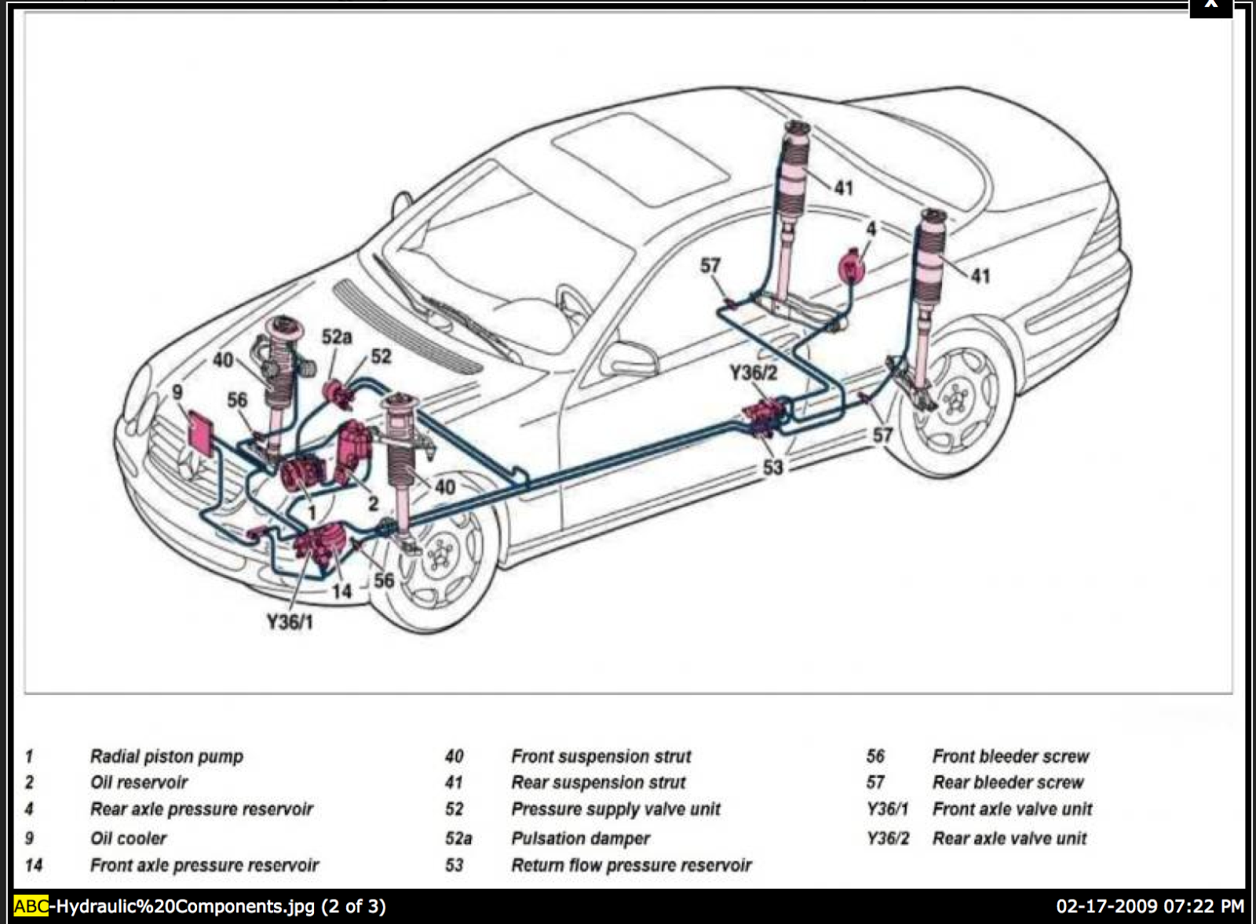

R230 Component Locations
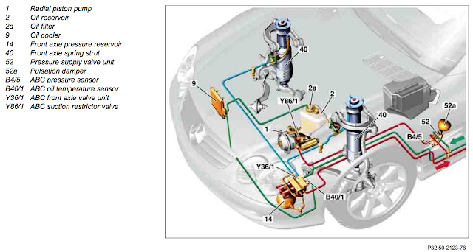

Component | Purpose
ABC Control Module | Controls the system.
Pump | Supplies hydraulic pressure for the system
Pulsation Dampener | Smooths out the pressure from the pump (P/N 2203270215)
Pressure Limiting Valve | Bleeds off any pressure in excess or 200 bars
Pressure Sensor | Reports the system pressure to the control module
Front Axle Valve Block | Controls letting fluid in and out of the front struts, based on  commands from the control module
Rear Axle Valve Block | Controls letting fluid in and out of the rear struts, based on  commands from the control module
Front Axle Accumulator | Stores fluid and pressure for the front struts, assisting the  pump by supplying the on-demand pressure needed to fill the  front struts. (P/N 2203270115)
Rear Axle Accumulator | Stores fluid and pressure for the rear struts, assisting the  pump by supplying the on-demand pressure needed to fill the  rear struts. (P/N 2203270115)
Struts | Connects the chassis to the wheels and the coil spring inside absorbs vibration. Pumping hydraulic fluid into the strut raises the vehicle.
Return Accumulator | Evens out the pressure on the return side of the hydraulic  system (once the fluid leaves the struts) (P/N 2203270415)
Return Pressure Check Valve /  Temperature Sensor | Maintains a minimum return side pressure of 10 bars, and reports the oil temperature to the control module
Oil cooler | A small radiator that cools the hydraulic fluid
Reservoir | Stores extra fluid for raising the ride height and pressurizing the accumulators and replacing any leaked fluid.
Strut position sensors | Reports to the control module the position of each strut
Ride height sensors | Reports to the control module how high each corner is
Motion sensors | Reports to the control module what the car is doing motion-wise (accelerating, slowing down, cornering)
ABC Hydraulic Design

Pictured below is the schematic for the hydraulic portion of the ABC system. I've found this diagram to be the most informative of any of the diagrams out there on the ABC system. Taking time to understand this diagram is key to understanding how the ABC system works, and will help you determine if the repair tech's assessment of the problem is correct.

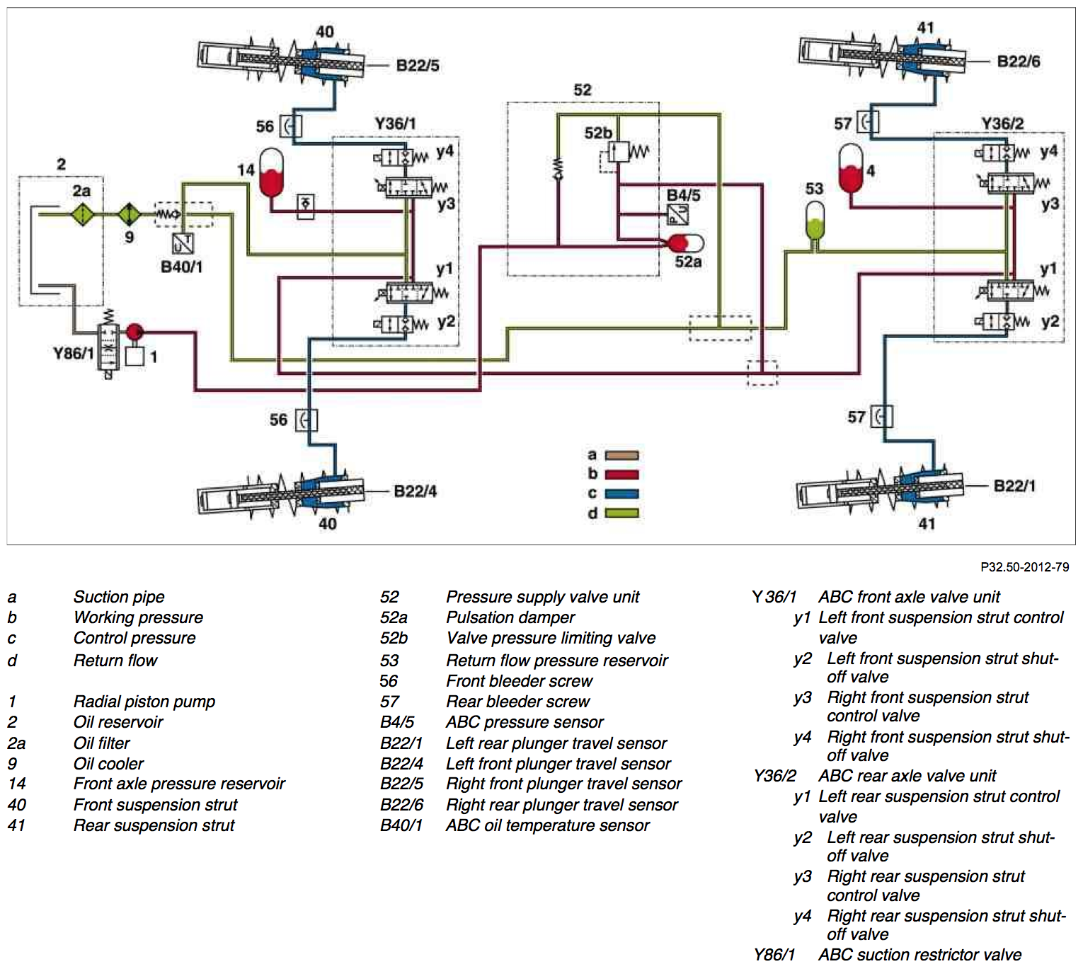

Going on a brief tour of the diagram…the ABC fluid starts its travel at the fluid reservoir(2). From the reservoir it is drawn into the pump(1). The pump pushes the fluid to an assembly(52) containing a pulsation dampener(52a) that reduces vibration, a pressure limiting valve (52b) that regulates the pressure at 200 bars, and a pressure sensor (B4/5) that reports the pressure to the control module. From there the fluid travels to the front and rear valve blocks(Y36/1 and Y36/2) which are used by the control module to manage the amount of fluid in the struts(40,41). Accumulators(4,14) are connected to each valve block to store fluid and pressure for filling the strut. The control module commands the valves to open or close which allows fluid to enter or leave the struts. When the fluid leaves the struts, it travels through a temperature sensor(B40/1), and then through the oil cooler(9) and back to the reservoir(2). An accumulator (53) helps even out the spikes in the return side pressure caused by the struts letting out fluid.

There are two generations of the ABC system. The first generation is from 2000 - 2006. The second generation was introduced in 2007. The main differences between the two generations are the valve blocks being improved and the pulsation dampener relocated to be attached directly to the pump.
While the locations of the components is generally the same across all models, there tends to be variation in how the components are positioned in terms of brackets, orientation, and so forth. Many of the pictures and diagrams are for the SL500, but the concepts apply to all ABC equipped models.

I know the SL model got the new ABC design starting in 2007. I'm not sure if the CL and S models got the update at the same time or not. The easiest way to see which ABC generation is on your vehicle is to look at the ABC pump on the upper right side of the engine. If a black sphere is attached to the pump, your have the second generation design.

ABC Electronics Design
There is also the electronics side of the design.

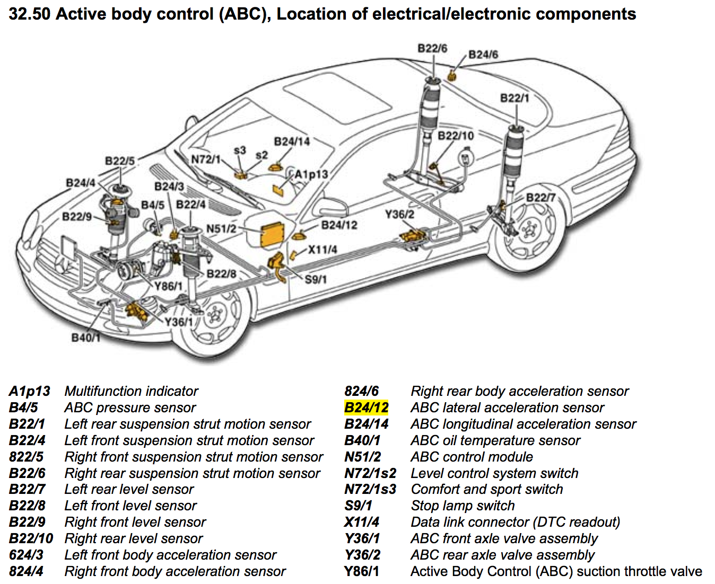

Each wheel well has a ride height sensor reporting to the control module how high the corner is. There is a sensor in each strut that reports how far extended the strut is. There are acceleration sensors that report how fast the car is speeding up or slowing down or changing direction. The control module monitors all these sensors and decides whether to add or remove fluid from each strut, with the goal of keeping the chassis level. It reevaluates 10 times per second.

All these sensors and valve solenoids are wired to the ABC control module. Failure of any of these sensors will disable the ABC system, causing an "ABC Drive Carefully" or "ABC Visit Workshop" message on the dash. Electronic issues with the ABC system are rather rare. The majority of issues are hydraulic related.
Mercedes dealerships and other workshops that work frequently on Mercedes vehicles will have the STAR Diagnostic System, referred to as SDS or STAR. It is software that runs on a laptop along with various interface cables. It was developed by Mercedes for their vehicles. It connects to the various control units on the car (like the ABC system), and can retrieve error codes, examine the current values of sensors, execute diagnostic routines, calibrate sensors, view the error history logs, etc. Fixing an ABC issue will often require SDS to get the error codes, so a trip to a workshop with SDS may be necessary. Handheld scanners on the market from Foxwell, ANCEL, etc are getting better every year and may be able to access the ABC controller and run diagnostic routines.

The major ABC components in depth
Pump

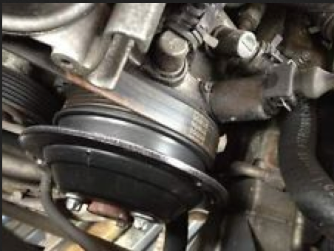

The power steering and ABC pump are integrated into one unit, referred to as a Tandem Pump. Although the two pumps share the same housing, they are separate components otherwise. It is possible for the ABC portion of the pump to fail but the power steering portion of the pump is fine (and vice versa). But if one portion fails, both have to be replaced since they are one unit.

There seems to be some consensus that the average life of a pump is around 60-80K. Like any component, some will fail sooner and some may last much longer. Pumps cost around $1,500 and $1,000 in labor to replace. There are rebuilt pumps on the market for around $500, so you can get your cost down to around $1,500 if you go that route and with an independent shop. There is also a seal kit available if you want to tackle rebuilding the pump yourself.

Integrated into the pump is a suction restrictor(Y86/1) or throttle valve. It is wired to the control module and open and closes based on the voltage supplied to it. The opening and closing of this valve controls the rate of flow from the reservoir into the pump.

The pump may fail one of two ways.
- It goes completely and cannot generate any pressure.
- The pump wears and cannot maintain steady pressure as it did before. It progressively gets worse, making error messages on the dash more frequent and more persistent.

The pump failing completely should be pretty obvious to diagnose. The ABC "visit workshop" or "drive carefully" message will appear shortly after the car is started, and the message will stay on. The car will not raise on command either. ABC control module error codes will indicate inadequate or no pressure.

If the pump is weak, you should also get ABC "Drive Carefully" and "Visit Workshop" messages, but they will be intermittent in nature. In many cases you can restart the car and the system will pressurize successfully, and the error message will clear. The car works normally again for a while. There will also be pressure related error codes logged as well.

Some owners report the ABC system operates fine when the car is cold, but the error messages start appearing after the car has warmed up. The reverse also seems to be reported. Temperature does seem to be a factor.

It is also suggested the suction valve may be the culprit, and not the pump itself. But unfortunately the valve is not sold separately, it comes with the pump. Check to make sure +5 volts or more is present at the suction valve if the pump is not producing pressure in order to rule out wiring or control module issues.

Some owners report a grinding or growling sound when the pump goes bad. A pump that is noisy at idle but get's quiet when under load (by pressing the ride height button) is also a sign of a worn pump.

It should also be noted that low pressure codes do not necessarily mean the pump. Accumulators can fail leading to intermittent low pressures (when hitting bumps). The suction restrictor valve could be malfunctioning. The pressure limiting valve could be malfunctioning. The pressure sensor itself could be malfunctioning.
If air gets into the system for some reason, such as accumulator failure or repair work or running the fluid reservoir dry, it is possible that there is an air bubble in the pump, preventing it from generating pressure. I recommend ruling out this scenario before spending $2500 to replace a pump. The procedure (priming the pump) involves pressuring the reservoir to force fluid down into the pump to help get it going again. If that fails, another option for pre 2007 models is to remove the pulsation dampener to eliminate any flow resistance, then start the car and wait for fluid to stream out the opening. Then stop the engine and replace the dampener.

The best way to know for sure if the pump is bad is to monitor the pressure while doing a rodeo. The rodeo will stress the system, and even a good pump will see about a 1/3 pressure drop at times. So if the car can get through the rodeo successfully, then the pump is probably fine. If there are still pressure related codes being generated after passing a rodeo, I would recommend investigating some of the other possibilities mentioned earlier.
Here are some DIY resources:
http://www.benzworld.org/forums/r230-sl-class/2557745-diy-remove-install-abc-pump.html
http://www.benzworld.org/forums/c215-cl-class/1925273-abc-pump-removal-guide.html#post13346657
http://www.benzworld.org/forums/attachments/r230-sl-class/895217d1397771677-abc-pump-information-change-part-number-r-i-high-pressure-pump..pdf
http://www.benzworld.org/forums/attachments/r230-sl-class/888065d1397470652-abc-pump-information-change-part-number-initial-operation-new-tandem-pump-ar32.50
Pulsation Dampener / Pressure Limiting Valve / Pressure Sensor Assembly

W215 (under passenger floor) | R230 (left front wheel well - towards rear of car)
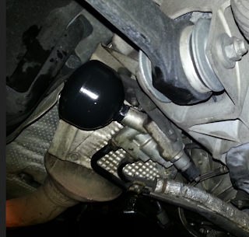 | 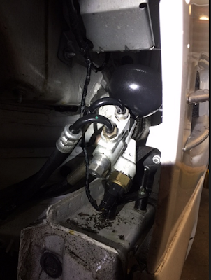

These three components are grouped together into the same assembly. They are the first set of components immediately after the pump.

There is a pulsation dampener(52a) attached to the assembly, part number 2203270215. It is a black sphere. It is similar in design to the other three accumulators in the system (nitrogen gas behind a rubber membrane), but much smaller. Since the fluid flow from the pump is "choppy" given the nature of its design, something is needed to smooth out these waves or vibrations in the fluid. This is the job of the dampener. Air behind the rubber membrane acts as a cushion and evens out the pressure, much like a gas shock absorber removes road vibration.
There is also a pressure limiting valve (52b) integrated into the assembly. It is a passive device, not actively controlled by the control module. It will open when the pressure exceeds its designed limit (~200 bars), allowing any excess pressure to be bled off. Its job is to help regulate the system pressure.

Lastly, there is a pressure sensor (B4/5) attached to the assembly, and it is wired to the control module. A resistor inside the sensor alters the voltage passing through the sensor based on the amount of pressure applied to it. At zero pressure the voltage is around 0.6 volts. At full pressure it is at 5 volts. The control module monitors this voltage, and infers the system pressure from it.

There is an inverse relationship between the voltage from the pressure sensor and the voltage supplied to the pump suction valve. When the voltage from the pressure sensor is low (the system needs more pressure), the voltage to the suction valve will be high (open up the valve and give me more), and vice versa.

On 2007+ models with the updated ABC design, the pulsation dampener is attached to the pump instead. Replacing is a little more difficult that on older models. The MB workshop instructions say to remove the pump first, but other owners have reported that loosening the bolts that attach the pump to the engine will create enough clearance to get the dampener off. No need to disconnect any hydraulic lines or remove the ABC reservoir.
So what can go wrong with these components?

1) The pulsation dampener fails. The rubber membrane inside of it eventually breaks down, and the dampening ability is lost. You will hear a humming or whining sound caused by the fluid vibration. The ABC system will function normally though, although the vibrations will stress the system if not addressed. I don't believe the control module will notice this, so no error codes or warning messages will appear. Just an annoying hum or whine, most noticeable with the top up and driving at slow speed around parking lots.

2) The pressure limiting valve could be opening at too high a pressure. There aren't any error codes for excess pressure, so the control module will likely not notice this. The control module will still regulate pressure by controlling the intake valve (suction restrictor) to the pump, so the system will probably work fine, except for spikes in pressure at times which would add stress to the ABC components. Valves of this nature are generally pretty reliable, so I don't this this is a very likely scenario.

3) The pressure limiting valve opens at too low a pressure. I don't think it is a likely scenario but it is theoretically possible. In this scenario the control module will sense the need for more pressure and tell the suction valve on the pump to open up, and meanwhile the pressure limiting valve will constantly route all that extra fluid back to the reservoir in an endless loop. If the pressure that this is occurring at is below the acceptable pressure to operate the ABC system, the control module will shutdown the ABC system and display a warning on the dash. If this endless loop is occurring at a pressure above the minimum but below the ideal, then the system will operate normally but the pump will be working extra hard. I'm guessing the control module would not notice this situation. It won't be able to tell the difference between a weak pump and a pressure limiting valve letting off pressure too soon. But a constant 5V at the suction valve would indicate the pump is working full throttle all the time.

4) The pressure sensor is not working correctly. It could fail. There could be a loose connection between the sensor and the control module. It could be sluggish in responding to pressure changes. Or it could just be wrong about the pressure it is sensing. The control module is able to detect a loose connection or a completely failed sensor and log an error code to that effect. If the sensor is bad, the ABC control module will report no pressure and/or an error code for the sensor, but the car will still rise when pressing the ride height button. If the sensor is reporting higher than normal, you will likely see frequent "too low" error messages since the system can not keep up with demand. The ride will cause get bouncy and handling will deteriorate since the system cannot add fluid to the struts fast enough to meet demands. If the sensor is reporting lower pressure than actual, then either 1) in extreme cases the control module will think the system is below normal operating pressure and will shutdown the ABC system along with dash warnings and error codes. It could mimic a pump failure. 2) if a minor case, the normal drops in pressure will be more exaggerated from the control module's perspective, leading to intermittent "drive carefully" messages and occasional ABC system shutdowns.
5) Occasionally the o-ring that provides the seal for the pressure sensor will fail, causing a fluid leak. There is a repair kit available (part number A2203201158) for approximately $80. Don't let the workshop convince you that you need to replace the entire assembly, a $1,250 part. If the kit is not available, the shop should be able to improvise something.
Here are some DIY resources:
http://www.benzworld.org/forums/r230-sl-class/2598178-hum-vibration-felt-through-brake-pedal.html
Accumulators

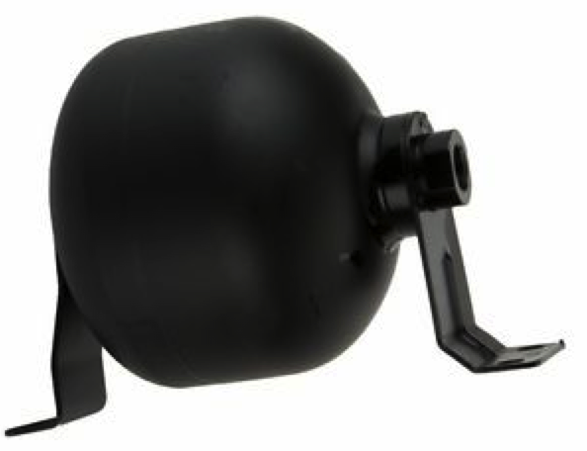

The accumulators (#4,#14,#53 on the hydraulic diagram above), are often referred to as a "air cell" or "nitrogen ball". They are black spheres that contain nitrogen gas (air) trapped behind a rubber membrane. Hydraulic fluid is allowed to travel in and out of the sphere based on the pressure differential between the rest of the system and the air on the other side of the membrane. The compressed air in the accumulator pushes back against the fluid and can either absorb pressure or supply pressure.

There are three accumulators placed strategically in the system. The two larger ones (4 and 14), part number 220 327 01 15, are connected to each of the two valve blocks and they provide the pressure necessary to add fluid to the struts when the valves open. The pump's job is just to keep these two accumulators topped off. These two are the most critical ones that will cause problems when they fail. The third accumulator(#53), part number 220 327 04 15, is often referred to as the "center" or "return" side accumulator. It is smaller than the other two and it's job is to smooth out the spikes in pressure that result when fluid is being let out of the struts. These accumulators are often overlooked since many techs do not understand their true function in the system. They are much more than just fluid repositories.
The pulsation dampener(52a), part number 220 327 02 15, is arguably an accumulator as well. The design is the same. Its size and position in the system has it serving a different purpose though. It is to even out the vibrations in the fluid from the pump. When it fails you get a hum or whine noticeable below 2000 rpm.
When you ask shop techs how many accumulators the system has, you often get different answers ranging from two to four, depending on whether they are considering the return accumulator and pulsation dampener in that count. So when talking to the shop about accumulators, it is best to clarify what they are referring to.

These accumulators wear out. Like any sort of wear part, how fast depends on a lot of factors. 60K-80K miles or about 10 years seems the norm from what I read. Your mileage may vary based on the age of the car, driving conditions, and so forth.

So, what can we take away from all this?

1) The dampener and return accumulator are important in that they smooth out the system pressure. Keeping those healthy will reduce stress on the system.

2) If the two larger accumulators(4 and 14, P/N 220 327 01 15) that provide pressure to fill the struts were to weaken or fail, then there will be momentary drops in system pressure. It will be most noticeable when the car hits a bump or drop in the road, which requires fluid to be added quickly to the struts to compensate. The control module is monitoring system pressure and when it sees the pressure drop, it puts the "Drive Carefully" warning on the dash. When the pump catches up moments later the message goes away. You may also get frequent "Too Low" warnings, since the system can't fill the struts fast enough to meet demand.
If an accumulator has failed, the accumulator will fill with hydraulic fluid and the air will begin to work its way out of the system. While this process is occurring, the free air in the system expands whenever the system depressurizes, pushing fluid to and out of the reservoir. The fluid level in the reservoir will drop during this phase. Eventually all the air gets out, and the overflow behavior will cease. But by now you should be getting very frequent "Drive Carefully" messages on the dash due to the lack of available accumulator pressure to help fill the struts. The air in the accumulator has now been replaced by fluid, and it cannot accept any more fluid when the car is started and the system pressurizes.
The ABC system can run fine with only one main accumulator working. If you look closely at the hydraulic diagram, you'll see there is a clear path for fluid to flow from the rear accumulator to the front valve block, and vise-versa. The two accumulators can assist each other. So if "Drive Carefully" messages only appear during extremely large bumps or drops in the pavement, then it is likely you have just one blown accumulator. If the problem has reached the point that you are getting drive carefully messages even on modest bumps, then it is likely both main accumulators have failed.
Shop techs who see "low pressure" codes in the logs often conclude that the pump needs replacement, when in reality one of the main accumulators have failed.
So how do you tell if your accumulators are in good shape?
Observing the dipstick levels. There are two notches on the dipstick. The lower one is when the engine is running, the upper one for when the system is off and fully depressurized. If your fluid levels are set correctly for when the car is shut off(the higher mark), and then you start the car and don't see the fluid level drop to at least the lower mark, then there is likely a blown accumulator(s). On my 2003 SL500 with 4 fresh accumulators, the level drops from the top notch to the bottom notch and an additional 1/3 below that, Each of the two main accumulators account for about 1/3 of the level drop. The pulsation dampener and return accumulator are smaller and together make up the last 1/3.
RPM drop when cycling through the ride heights. The accumulators, when healthy, have enough capacity to lift the car to the next level when the ride height button is pressed. If you press the ride height button once, and you hear a RPM drop during the raising process, then you may have a blown accumulator. The pump is having to step in and help lift the car.

Visual inspection. This will require removal of the accumulator.If an accumulator has blown, it will be full of fluid, and you can reach a considerable distance into it with a wire or screwdriver. But if you are going to go through the work to pull the accumulators, I recommend just replacing them regardless of what you find, as a preventative maintenance investment. Accumulators cost about $150-200 each.
Dash warnings and low pressure error codes in logs. If just one of your accumulators is blown, you will start seeing occasional dash warnings when hitting only very hard bumps or drops in the pavement. When the second one blows the messages will start appear very frequently and on even modest bumps in the pavement.
The locations of the valve blocks and accumulators vary between the S, CL, and SL models.
The front accumulator and pulsation dampener in the front wheel well is a fairly easy job to replace. It takes about an hour for a SL500, and maybe a little longer for other models if you need to loosen some brackets to the valve block to get better access to the accumulator. The pulsation dampener on the opposite side of the wheel well is easily accessible. A set of slim or thin wrenches will be required to break it loose. From there in screws off/on like a light bulb.
The rear accumulators are fairly easy as well. For the R230 they are both located in a rack that slides out of the left rear wheel well, just behind the driver. There is a bracket below the rack that holds some hoses in place. Remove that and then a nut at the top of the rack that holds the rack in. After those are removed you can slide the rack out and get easy access to both the rear accumulator(the larger one) and the return accumulator (the smaller one). Once replaced, slide the rack back in, put the top not back and the bracket on the hoses, and your done. About 60-90 minutes. A set of slim wrenches are necessary to break loose/tighten the return accumulator.
To recap, there are two common symptoms that point to your accumulators failing. The brief "ABC Drive Carefully" messages on the dash, and the reservoir overflowing a few minutes after the car is shut off.

Here are some DIY resources:
http://www.benzworld.org/forums/r230-sl-class/1742594-r230-abc-rear-valve-block-accumulator.html
http://www.benzworld.org/forums/r230-sl-class/1996449-abc-change-front-rear-pressure-reservoirs.html

Valve Blocks

The valve blocks control the amount of fluid in each of the 4 struts. There are two valve blocks, one for the front struts and one for the rear struts.

Pre 2007 Valve Block | 2007+ Valve Block
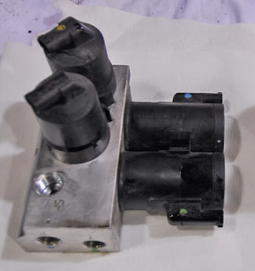  This model has been discontinued. | 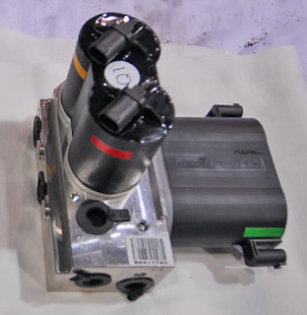  This is the updated design and is compatible with  the pre 2007 ABC system as well. This is  the valve block you get when you order a new  replacement.

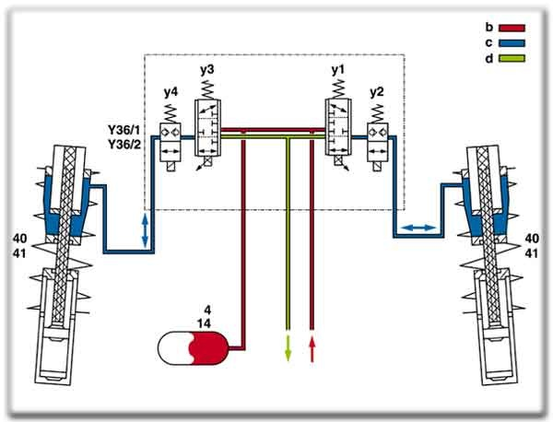

For each strut, there are two valves (Pre 2007 version shown here)

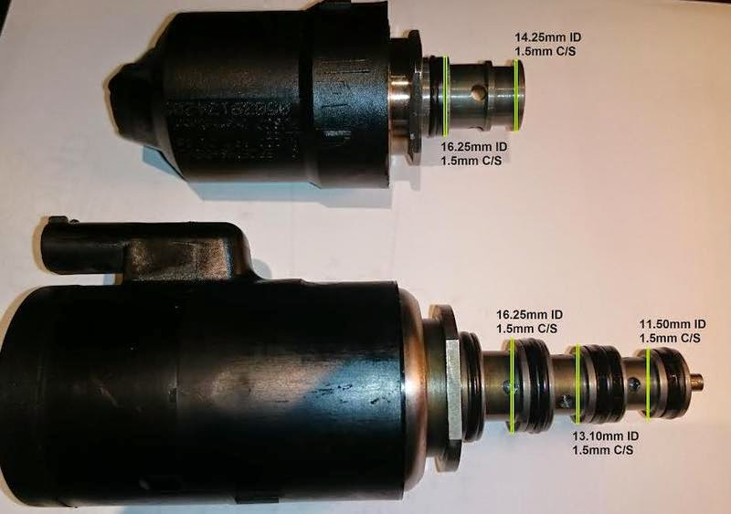

The main control valves (y1,y3 in schematic, lower valve in picture) is a 3-position valve. In the outer position it allows fluid to enter the strut, in its center position it closes off the strut, and in the inner position it allows fluid to leave the strut. When the ABC system is active, this valve is doing all the work.

The other valve (y2,y4 in schematic, upper valve in picture) is the shut-off valve that sits between the main control valve and the strut. It's purpose is to lock the struts at their current fluid levels when the ABC system is not in operation. When the car is not running or the transmission is not in gear, this valve is closed. When the car is put into drive or reverse, the valve will open and allow the fluid levels to be managed by the main control valve. If the control module senses a malfunction and disables itself, it will also close this shut-off valve for safety reasons.
So each valve block has 4 valves in it in total. These valves open and close based on voltage being supplied to them by the ABC control unit.

These valve blocks rarely fail outright. What happens is the o-rings in the valve deteriorate (most likely), or gunk has built up in the valve block (less likely). Either way, the valve no longer makes a good seal. As a result, fluid slowly escapes out of the strut, past the shut-off valve (y2) and the main control valve(y1) and returns back to the reservoir. This causes the strut to lower and the corner of the car to sag while parked.
It is important to remember that the car sagging after a couple of weeks is completely normal, according to Mercedes. The tolerances in the design of the valve block will allow some leakage to occur over time. The height should return to normal when using the ride height button or putting the car in gear.
If a o-ring in the valve block is bad, it is also possible for a corner(s) of the car to raise a little shortly after you shutoff the car. The reason being is that it takes a few minutes for the pressure in the system to dissipate, and during that time fluid could get past the seal and flow INTO the strut.
It is possible (although rare) the car sagging is a fluid leak, such as the line between the valve and the strut, or a leak in the strut itself. If the leak is severe enough to cause noticeable sagging while parked, there should be obvious signs of the leak, so visually check the strut to rule out it leaking fluid. If the strut is leaking, there should also be a drop in fluid level in the reservoir.

When the car is running, the control module will compensate for any leaks in the valves. It is constantly monitoring levels and adjusting as necessary. The sagging would only occur when the car is parked and shut off.

If you are having issues with a corner of the car not being at the correct level when running, or exhibiting other odd activity, then you probably have a sensor issue or calibration issue.

Sometimes a "C1531"suspension strut moves although locking valve is closed" error code will get logged..most likely while is stop and go traffic or idling at stop lights. It generally indicates the valves are sticking or jamming from being held still too long. 2007+ model years have a software update to periodically move the valve a little to reduce this. So you probably shouldn't get too concerned about these errors in your logs unless you notice symptoms.
Unless the sagging problem while parked is severe, it is not an urgent problem that you have to rush to the repair shop for. You can monitor the situation over time and decide when it has reached the point you want to fix it. In the meantime be careful not to let the corner sink all the way down while parked, as the wheel well may come into contact with the tires. Be sure to park with the wheels oriented straight ahead to avoid wheel well damage, and to start the car periodically to pump up the strut.
You should also be sure to keep an eye on the reservoir fluid levels. If too much fluid leaves the struts, it may overflow the reservoir. Then when you start the car and the struts are pumped back up, the system may be extremely low on fluid, which may cause pressure problems and/or damage the pump. It would be wise to carry a spare quart of ABC fluid in the trunk for this situation.
If and when you have to fix the valve blocks, you options are to:

1) Filter the fluid (requires two filters) and perform a rodeo (a test that exercises the system) . Cost would be around $200-300. If the cause is debris rather than an o-ring, then it may dislodge some debris from the valves, but the results will be marginal and probably temporary. Sort of like trying to clean a fry pan by just running water over it. If the ABC fluid is older that 40K miles, many on the forum would suggest replacing the fluid as well (about $250+labor).

2) Overhaul the valve assembly (Pre 2007 version). This is not an approved MB procedure. Many owners have reported success in pulling the valves and cleaning them. Replacing the o-rings is also a good idea. There are DIY write-ups and a youtube video as well. Your local independent shop may be willing to do this for you, with no guarantees of course. Parts cost would be minimal and labor cost around $1,000.
Although usually successful, there is no guarantee of success with this. Sometimes the cylinder walls may be scored or deformed, so new o-rings may not be enough to allow the valve to create a good seal.

Some good o-ring sources are APG (www.apandg.com), and "The O-Ring Store" (www.theoringstore.com). You can also find rebuild kits for $30-$50 on the internet with all the o-rings and gaskets needed.

O-Rings Required for Rebuild: Buna 90 (Nitrile) O-Rings
APG part # | Cross-Section | Inside Diameter | Outside Diameter | Height | Quantity per block
H90018 | .070 | 7/8 (0.739) | 1 | 1/16 | 4
H90016 | .070 | 5/8 (0.614) | 3/4 | 1/16 | 6
H90015 | .070 | 9/16 (0.551) | 11/16 | 1/16 | 2
H90014 | .070 | 1/2 (0.489) | 5/8 | 1/16 | 4
H70013 | .070 | 7/16 (0.426) | 9/16 | 1/16 | 4
There are also some spacers that may need replacement - (Buna-N 70 square cut o-rings)
They are APG part numbers SH70013, SH70014 , SH70015 , and SH70016. One set per block.
Tip: Be careful to note which o-rings came from which position on the valve when removing them.
Tip: The square spacers are prone to breaking when installing. Ordering a few extra may be wise.
3) Replace the valve block assembly. This will run you around $2,000. If it is a warranty repair or saving money isn't a goal, then this is the best option to fix the problem. You can also find rebuilt or refurbished valve blocks on the internet for $200-$300 each.

Anyway, valve blocks leaking is a very common ABC problem and is also the easiest problem to diagnose. If the car sags when parked, and there are no signs of fluid leakage, then you have a leaky valve block. There aren't any other explanations.
I've read numerous reports where repair shop told owners they need new pumps or struts to fix this issue. If you are told this go to another repair shop since the tech clearly doesn't understand the design of the ABC system and is grasping at straws(at your expense).
Here are some DIY resources:
http://www.benzworld.org/forums/r230-sl-class/2710449-abc-valve-block-reseal-sl55-lots.html
https://www.youtube.com/watch?v=vqkfz2LRoPQ
http://www.benzworld.org/forums/r230-sl-class/1635269-abc-valve-cleaning-diy.html
http://www.benzworld.org/forums/r230-sl-class/1742594-r230-abc-rear-valve-block-accumulator.html

Struts

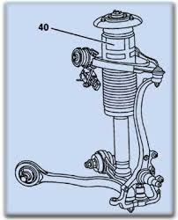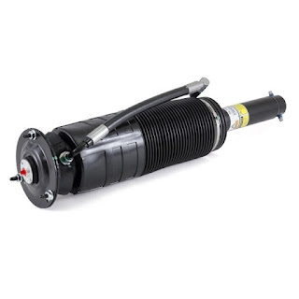

The ABC strut contains a spring and a shock absorber, just as standard struts do. As in typical struts, the spring does the work of supporting the vehicle's weight and absorbing impacts from bumps in the road, and the shock absorber keeps the spring from oscillating or "bouncing".
The ABC strut goes a step further, and adds a hydraulic fluid chamber so the height can be adjusted by adding or removing fluid. This enables the ABC control module to adjust the height of each corner of the car, and it does so at the rate of 10 times per second.
While many suspension systems offer the ability to adjust the stiffness of the shock absorbers, it is still a compromise between ride comfort and handling. The ABC system approaches the problem differently. It
constantly reads the inertial sensors and the ride height sensors for each corner, and adjusts each strut's height independently to keep the chassis level and provide optimal handling. It's why the car doesn't lean when cornering, and why the nose doesn't dive when you hit the brakes. And it does all this without compromising comfort.
But these benefits do come at a cost. It is a more complicated system, and like most hydraulic based systems, it is prone to hose leaks and for seals and o-rings to break down and pumps to wear out. But in the final analysis, I think the benefits are worth it.
But back to the strut in more detail.
Inside each strut there is also a electronic sensor, referred to as the strut travel sensor. It reports to the control module how far extended the strut is. The control module compares this to the ride height sensor in each wheel well, and to the inertial sensors to decide how much fluid should be in the strut at that moment. This travel sensor can fail. Generally when this happens the control module will put the ABC error message on the dash, and will log an error code pointing to the offending sensor. If the ABC system is having difficulty maintaining the correct height for a corner of the car, this travel sensor reporting incorrect information is one of the possible explanations. If errors pop up on the dash intermittently while entering or leaving your driveway, this sensor is often the culprit. Fixing it requires replacing the entire strut. It just isn't cost effective to disassemble a strut to replace the sensor.

These struts will eventually wear out. The seals and o-rings will eventually develop leaks. To get as much life out of them as possible, make sure you are using fresh hydraulic fluid, and inspect the boots (the rubber accordion like cover) to make sure there are no rips or tears. Dirt or dust inside the strut will wear out the seals quickly. Once they do leak, there isn't much you can really do about it except to replace the strut. Mercedes charges around $1,250 for a replacement strut, and around $800 or so in labor to install. A popular route is to go with Arnott struts, which is a remanufactured strut with a lifetime warranty for around $500, and have an independent shop install it.
Sagging issues are not caused by a bad strut (unless fluid is leaking externally). There is only one entrance/exit for fluid into/out of the strut, and the control of that flow is at the valve blocks. The typical sagging issue occurs when the seal in the valve is bad, causing fluid to escape out of the strut and go back to the reservoir. There are no components within the strut itself where the failure would lead to sagging issues.
Replacing the strut is fairly straightforward. There is just one hydraulic connection and one sensor connection. Beyond that it is not much different than any other strut to physically remove and install. After installation, it will require extra steps to fill the strut with fluid and bleed the air out of the line. And the SDS system (or a scan tool capable of executing ABC control module commands) will be needed to recalibrate the ride height. An alignment may also be necessary.
When the ABC system shuts down due to a system failure, owners report what they describe as a very bouncy ride, nicknamed the "tuna boat" ride. The reason for this is that the gas shock absorber integrated into the ABC strut is smaller than usual and only handles oscillations at frequencies above 5 Hz (5 oscillations or 5 bounces per second). The ABC control module is responsible for handling oscillations below 5 Hz, and it does this by rapidly adjusting the fluid level in the hydraulic fluid chamber. When the ABC system is shut down, the dampening ability below 5 Hz (the larger oscillations or bounces) are not being handled anymore. You are in effect now driving a car with no shock absorbers!
Reservoir

The purpose of the reservoir is to provide a place to store fluid when not in use. The green arrow points to the dipstick location. The dipstick has two marks. The lower one for when the engine is running. A higher one for when the system is shutoff. When all is well and there are no leaks, you should never have to top off the fluid levels. Dropping fluid levels indicates a leak in the system somewhere or a blown accumulator.  The fact that the dipstick mark for when the car is running is lower than the one for when the car is off indicates it is normal for some fluid to flow from the ABC system back to the reservoir when the car is shut off and the system depressurizes. Remember that fluids do not compress. Only the air in the accumulators will compress. What happens is that the accumulators hold fluid when the system is under pressure, and the amount of fluid returned is proportional to the amount of fluid being held there during operation. It can take 5-10 minutes for the system to depressurize, so be patient before taking measurements or beginning repairs. | 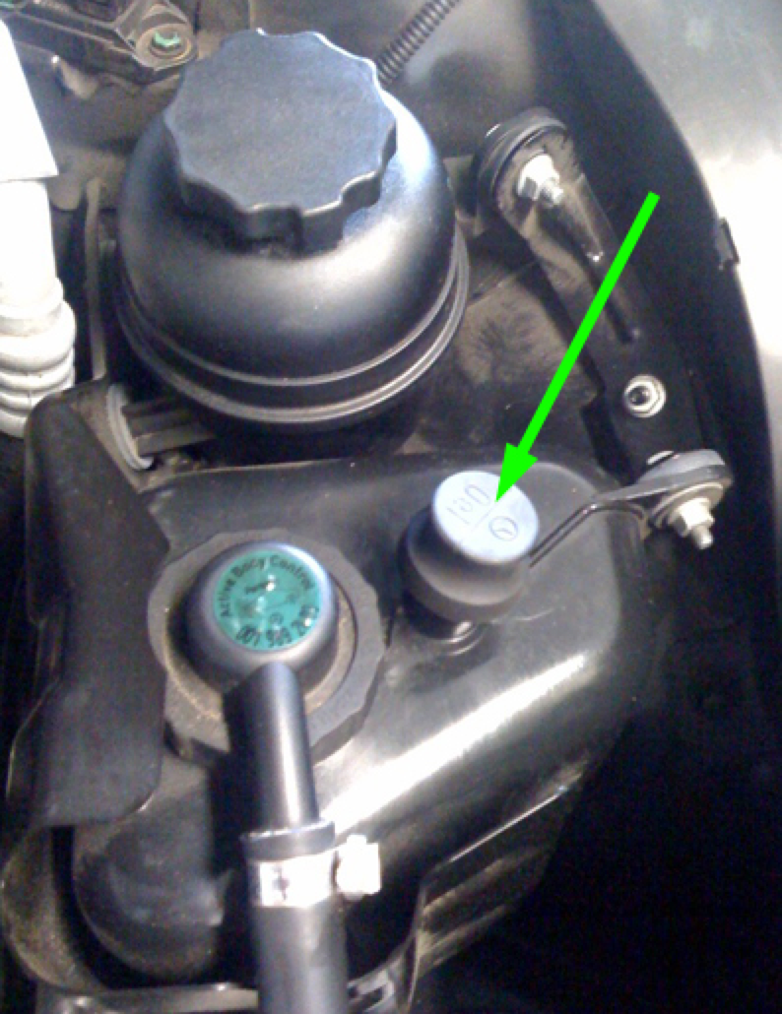

Sometimes, the reservoir will overflow after a drive. If this happens, there are two possible explanations:

- It is a common to interpret the marks on the stick an cold and warm like coolant levels markings, which is incorrect for ABC fluid levels. If the reservoir was filled to the top level on the dipstick while the engine is running, the reservoir may overflow when the engine is shut off. (remember fluid is drawn into the accumulators when the engine is running, and the fluid returns back to the reservoir when shut off).
- An accumulator membrane has blown. Then when the system depressurizes the gas expands, pushing fluid into the reservoir and overflowing it. Eventually the air works out of the system, and fluid replaces the air in the accumulator. As a result you will see a drop in the fluid level in the reservoir. This is the most common reason.

So the take away is that the reservoir overflowing fluid out the dip stick cap is a pretty clear sign an accumulator has failed. If you also find you need to keep your fluid levels somewhat below normal to keep the reservoir from overflowing, it indicates a failed accumulator in the process of losing all its air.

It is also important to keep an eye on fluid levels if you have a blown accumulator or a leak in the system. If the level of fluid gets too low in the reservoir, the pump will start ingesting small quantities of air along with fluid, leading to a loss of pressure and ABC warnings on the dash.

It is important to keep this fluid clean and fresh. As time goes by, the o-rings, seals, hoses, accumulator membranes, struts, and other rubber components shed microscopic debris into the fluid. This debris shortens the life of the components in the system, especially the valve blocks. This gunk tends to deposit on the valve surfaces preventing a good seal, and interfere with optimal lubrication within the pump. Microscopic metal shavings will also accumulate in the fluid, acting like sandpaper for your pump bearings and valve block o-rings.
It is extremely important to keep contaminants out of the ABC fluid when checking the level. Wipe the area around the dipstick clean, and use a lint free cloth to check the fluids. Any contaminants that get into the reservoir will make a trip through the ABC system before encountering the filter.
Some owners claim that by keeping the ABC fluid pristine they have been able to make it to well over 120,000 miles without ANY repairs needed to the ABC system. The evidence is anecdotal, but it does make some sense. So flush the fluid when it shows signs of wear (turns dark in color).

Here are some DIY resources:
http://www.benzworld.org/forums/r230-sl-class/1899049-abc-fluid-filter-change-diy.html
http://www.benzworld.org/forums/attachments/r230-sl-class/888001d1397460364-abc-pump-information-change-part-number-230-abc-bleed.pdf

Hoses

There is a considerable amount of hoses and piping traversing the vehicle. Each connection point presents an opportunity for a leak to occur. A typical hose leak repair will cost you $200 - $500.
Some people like to speculate that a hose blowing will cause the car to drop suddenly onto its wheels and cause a crash. This is highly unlikely. The control module has to energize the shutoff valve for each strut to allow fluid to enter or leave the strut. If the control module senses anything wrong (like a pressure drop), or the control module itself would fail, then the voltage to the shutoff valves will be interrupted and the valves will close, locking the fluid in the struts. Conceivably the line between the valve and the strut could fail, or the strut itself could fail, but I suspect these parts are designed not to "blow" altogether, giving you enough time to pull over.
Some sections of hose/piping that run through tight spaces near the engine can be extremely expensive to repair..sometimes over $2,000. An alternative to replacing these lines is to repair the existing line by visiting a hydraulic shop and have them patch the bad section of line by fitting a couple of compression joints. Or even run a completely new line along a different route between the two ABC components. Some independent repair shops may have sufficient hydraulic skills to perform the repair as well. You may be even to find some kits on-line to replace commonly failed lines...particularly that expensive line that runs through tight spaces under the engine.

See this thread for more details:
http://mbworld.org/forums/cl55-amg-cl65-amg-cl63-amg-w215-w216/505844-diy-abc-pressure-hose.html
The Control Module

The control module is the brains of the system. It is constantly monitoring the inputs from the sensors, and adjusting how much fluid should be in each strut to meet the needs of the current situation.  The "sport" switch changes how aggressive the control module should be about countering the leaning effects.  The driver can also increase the ride height by either 1/2 inch or 1 inch. This is useful when more clearance is needed, like driveways and speed bumps. | 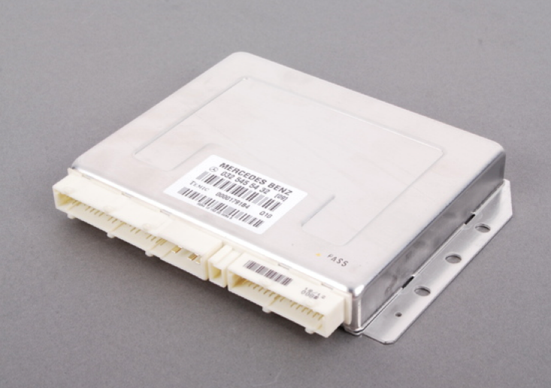

If the control module senses inadequate pressure to operate, or if any of the sensors provide in-plausible data, the system will shut itself down for safety reasons. The offending sensor will be logged for later retrieval by the SDS system (or a scan tool capable of accessing the ABC control module).
Loose connections can happen - sometimes corrosion builds on the connectors, so pulling the connectors and cleaning the contact points may help. Bad sensors or loose connections will often result in an error code with "fault in component" as part of the description. Values of 255 from a sensor generally means "no reading" or "bad input".
Ride Height Sensors

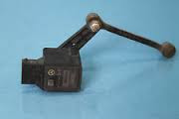

In each wheel well you find a ride height sensor. It reports to the ABC control module how high the corner of the car is. If a corner of the car gets too low, an "ABC Car Too Low" message will appear on the dash.
Usually this message indicates a low pressure issue preventing the ABC system from keeping up with demand, but the sensor can go bad and give false information or no information to the control module. If you suspect one of these sensors is the problem, do a visual inspection to make sure the linkages are not damaged or loose. Also check the wiring connector to make sure is on tightly and the connection surfaces are not corroded. If you suspect the sensor is bad, you might try swapping it with one from one of the other wheel wells, and see if the problem moves.
Strut Travel Sensors

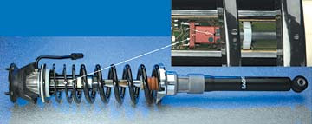

Imbedded inside each strut is an electronic sensor that measures how far extended the strut is. It reports this to the ABC control module. The control module uses this information along with other sensor inputs to decide how much fluid it wants in the strut.
These sensors can fail. They can report incorrect information, or can fail altogether. When these sensors start generating errors, the ABC warning message will appear on the dash. If dash messages start appearing intermittently on the dash and the messages correspond to strut movements, it is likely the strut travel sensor is failing or the ride height sensor.
When the travel sensor starts to go, you will often see symptoms like the errors happening when the car is first started, and after driving a short distance the car is fine for the rest of the day. Or the errors occur or clear up when parked on inclines, or when entering/leaving your driveway.
These sensors cannot be replaced. You will need to replace the entire strut.
Using SDS (or a scan tool capable of accessing the ABC control module) is the best way to identify the bad sensor. If you want to try to identify the bad sensor without SDS, I suggest the following: First try to find the corner of the car with the bad sensor. Try triggering the error by pushing/pulling up/down on each corner of the car to exercise the sensors to cause the error. Keep in the mind the car will need need to be running and in gear while you do this. You also might try using a jack and try raising the corners of the car one at a time to see if you can reproduce the error message. Once you identify the corner with the bad sensor, the next step is to determine if it is the ride height sensor or the travel sensor. Try swapping the ride height sensor with the one on the other side. If the problem moves to the other side, the issue is probably the ride height sensor. If the problem stays at the same side, then it is likely the travel sensor.
ABC Control Module Error Codes

The control module will log errors, which can be retrieved later by the SDS diagnostic computer (or a scan tool capable of accessing the ABC control module). Below are the most common ABC codes and what they indicate.

Error Code | Description | Explanation
C1525-001  C1525-002  C1525-004  C1525-008 | Critical Vehicle Level  C1525-001 Front Left  C1525-002 Front Right  C1525-004 Rear Left  C1525-008 Rear Right | The corner of the car got too low. This can be caused by:  1) the corner sagged while parked, and when the car was started the control module noticed the corner was low and logged the error code  2) The ABC system was unable to keep up with demand due to inadequate pump or accumulator pressure. If so, there will usually be pressure related error codes logged as well.  3) A control valve in the valve block is sticking, causing erratic control of the fluid level in the strut.  4) Although rare, it could be that the level sensor is reporting incorrect values. If everything checks out as far as pump pressure and accumulator health, then consider the sensor or wiring could be bad. Try swapping with the sensor on the other side to see if the problem moves to the other side.
C1526-001  C1526-002  C1526-004  C1526-008 | Fault in hydraulic circuit  C1526-001 Front Left  C1526-002 Front Right  C1526-004 Rear Left  C1526-008 Rear Right | The valves within the valve block that controls the strut fluid levels may not be functioning correctly.
C1531-001  C1531-002  C1531-004  C1531-008 | suspension strut moves although locking valve is closed  C1531-001 Front Left  C1531-002 Front Right  C1531-004 Rear Left  C1531-008 Rear Right | This usually indicates a sticking valve block. Some of these errors are to be expected if in stop and go traffic. But if these error codes are frequent or other observable problems are occurring, then should address the issue.  The block is likely dirty or the o-rings have deteriorated.
C1353-001 | Fault in component Y86/1 (ABC suction restrictor valve) | The valve that controls the amount of fluid to let into the ABC pump has an issue. Either the valve has failed or there is a wiring problem.
C1526-016 | malfunction in PSI supply | Indicates the pressure in the system dropped too low. Could be either the pump or the accumulators.
C1525 - 032 | Piston Stroke sensor calibration failed | there is a piston stroke sensor (strut travel sensor) inside each strut. Check the wiring to the sensor. If the sensor has failed you will need to replace the strut.
C1526 -064 | Load Calibration failed  (system needs to be calibrated using SDS (or a scan tool capable of accessing the ABC control module)) | Try to recalibrate the ride height.  The calibration settings entered into SDS may be invalid.
C1126,C1127,C1128,C1129 | Fault in component - Plunger travel Sensor  C1126 - left front  C1127 - right front  C1128 - left rear  C1129 - right rear | The travel sensor inside the strut has failed or there is an issue with the wiring or connections.
C1148 | Fault in component B4/5 (ABC pressure sensor) | The pressure sensor has failed or there is a wiring issue or loose connection.
C1147 | Fault in component - oil temperature sensor | The oil temperature sensor has failed or is sending data intermittently or there is a loose connection.
C1132,C1133,C1134,C1136 | Fault in component - level sensor  C1132 - left front  C1133 - right front  C1134 - left rear  C1136 - right rear | There is a ride height sensor in each wheel well that reports the ride height to the control module. Either the sensor has failed or there is an issue with the wiring or a loose connection.  Try swapping the sensor with the one on the other side of the vehicle and see if the problem moves or not. If problem moves then replace the sensor. Else look into wiring issues.
C1343,C1344,C1345,C1346 | Fault in component - strut control valve  C1343 - left front  C1344 - right front  C1345 - left rear  C1346 - right rear | The control valve (the 3 position valve that controls the fluid level in the struts) has a problem.  It may be jammed, or has failed, or the electrical connection is bad.  Cycle the ride height to see if the corner raises and lowers. If so the problem may be intermittent .  If it is not a simple electrical issue then your options are to try rebuilding the valve block on the assumption it is sticking at times, or replace the valve block. You can't replace individual valves.
C1347,C1348,C1349,C1350 | Fault in component - strut blocking valve  C1347 - left front  C1348 - right front  C1349 - left rear  C1350 - right rear | The shutoff valve (the 2 position valve that closes when the ABC system is not in operation) has a problem.  Remedies are the same as for the control valve above on the line above.
C1353 | Fault in ABC Suction Restrictor Valve | The valve that controls the rate of fluid flow from the reservoir into the ABC pump has an issue. The valve is integrated into the pump and if it fails, you need to replace the pump.
C1525-16 | Level Calibration was not successfully carried out | Invalid settings were entered
C1525-64 | System pressure too low | The ABC pump may be weak, or one of the two main accumulators may be blown.  On extremely harsh bumps this error may occur so not a major issue unless these codes are frequent.
C1526-32 | Oil temperature too high or sensor is faulty | Check to make sure air flow to the ABC fluid radiator is not obstructed.

Maintenance
Mercedes says this system is maintenance free. But nearly everyone on the message boards agree that the ABC fluid should be replaced on a regular basis. How frequently is a subject of debate?
Clean fluid is clear with a green tint. If the fluid has turned brown it is because it is full of loose microscopic particles floating with the fluid. If it is black it will likely lead to problems. These particles will settle on surfaces you do not want them too, especially in the valve blocks. My personal opinion is that the fluid and filter should be replaced when the fluid begins to darken. Sometimes it may take two flushes to get the system clean.
It will cost around $200-300 dollars to purchase the 10 pints of Pentosin CHF 11S fluid, and about $50 for a new filter. There are DIY write-ups on the web on how to change out the fluid.

Here is an excellent description (message #6 of this thread) on why the fluid should be kept clean:
http://www.benzworld.org/forums/r230-sl-class/1899889-great-article-importance-abc-fluid-changes.html
It is somewhat biased in that it is from a company that sells a filter with a magnet in it, but I agree with their conclusions for the most part. I'm not sold on the need for a magnet, since the filter should catch the same particles the magnet does. But it can't hurt either. They concern themselves more with metal shavings, but the rubber debris that all the rubber components shed over time also contributes to the eventual failure of components. The fluid also absorbs moisture over time which will lead to rust accumulation within the pump. So if you decide to add the magnet filter, don't let it be a substitute for regular flushes.
Dirty fluid will cause the valve blocks to develop leaky seals and the car will start sagging overnight. The pump bearings will also experience excessive wear and will lead to the pump failing sooner than normal. So ignore the MB dealer when they tell you flushes aren't necessary. Flush this ABC fluid regularly!

Like brake or coolant or transmission fluid flushes, sometimes problems appear shortly afterwards. There may be a cause and effect relationship, or just plain coincidence. It is hard to know one way or the other. The flushing procedure for ABC doesn't introduce any pressure or unusual flows or anything outside the norm. It is simply diverting the return line to a bucket while adding fresh fluid to the reservoir until the fluid clears up. It is hard to imagine the process would dislodge gunk that would otherwise have stayed put. But there have been reports of problems after flushes, and I suspect this has more to do with the rodeo that shops often perform after flushing the fluid (see caution on rodeos below). The risk/reward decision is yours to make.

For checking the fluid levels, I recommend the following: 1) Make sure the ride height is at the normal setting (no lights on the switch) before taking the measurements. 2) With the engine off for at least 10 minutes, note the fluid levels relative to the upper dipstick mark. Adjust if needed. 3) Replace the cap, start the engine and let run for a few minutes. 4) Check the dipstick again. It should be near the lower dipstick mark. You can infer the overall health of the 4 accumulators in the system by the amount of fluid level drop. The more it drops, the better.
You should also drive the car regularly, at least once per week if not more. The reason being is that hydraulic systems do better when used regularly. All the hydraulic o-rings and seals do not do well with prolonged inactivity. Seals dry out faster and stick to the cylinder wall, and microscopic pieces are torn off the next time it is moved. The o-rings in the valves become deformed from being held in the same position for extended periods of time. Gunk gets the opportunity to settle and harden on surfaces and then damage o-rings when they move over that surface. I understand that this is often the 2nd/3rd/4th car for many and only driven during summer months. Just understand there is considerable cost to leaving the car sit over the winter. The most likely impacts being worn/dirty valve blocks causing corners to sag, and seals around the strut piston have excessive wear and develop leaks.
Purging air from the system
The system will purge itself of air in the system over time. If you were doing some work and want to get the air out immediately, you can do so by using the ride height button. Cycling through the levels about 15 times is sufficient to get most of the air out of the system. The air escapes through a pinhole in the dipstick cap. The rest will work its way out over time. A rodeo procedure can help speed the process along, but it is NOT necessary. While the system is generally self-purging, it is possible for air to get trapped in the struts since the hydraulic path to each struts is a dead-end. There are bleed screws located in each wheel well that can be open to bleed air from these segments of the hydraulic circuit.
Caution on Rodeos
Rodeos are a useful diagnostic procedure, sort of like a cardiac stress test is. It puts the system under heavy load and the SDS (or a scan tool capable of accessing the ABC control module) tool monitors pump pressure and watches for errors to occur. You should use this procedure sparingly. It puts the struts through travel ranges and components under loads that are not typically seen in day to day driving. Sometimes a component may break down during the test. Or a piece of gunk or metal shaving may break loose and then get lodged in a valve block, causing sagging issues. Now it can be argued that the rodeo exposed a component that was about to fail anyway, but who really knows for sure.
Also, some shops or techs will often perform rodeos as part of fluid flushes or replacing components in the ABC system. And to their defense...for many repairs the workshop manuals call for a rodeo to be performed afterwards to purge air and check for normal operation. But it really isn't necessary...especially for flushes and simple repairs. Any air that got into the system during a repair can be purged from the system by simply cycling through the ride height levels and adding back any lost ABC fluid. The shops are going to do what they think best. But my advice is to perform rodeos sparingly and discuss with the shop whether or not a rodeo should be done as part of the repair.
Typical Repair Costs for each ABC component (Dealer Pricing)

Item | Parts | Labor | Cost
Pump | 1500 | 1000 | $2,500
Valve Block | 1250 | 1000 | $2,250
Front Accumulator(R230,W215) | 200 | 500 | $700
Rear Accumulator (R230) | 200 | 1000 | $1,200
Rear Accumulator (W215) | 200 | 250 | $450
Return Accumulator (R230) | 200 | 1000 | $1,200
Return Accumulator (W215) | 200 | 250 | $450
Pulsation Dampener (R230, W215) | 200 | 250 | $450
Pressure Limiting Valve + Pressure Sensor Block | 1,000 | 500 | $1,500
Struts | 1250 | 750 | $2,000
Note: remanufactured pumps are available for around $500, and rebuilt struts are available for around $500 each as well. Independent shops can reduce your labor cost 20% - 40%.

With the exception of the pump, the other components of the ABC system (the valve blocks, accumulators, and struts) are in easy to access locations, and replacing them requires only basic mechanical skills. There are do it yourself write-ups and videos on the web, and support forums where other owners can provide advice.
So if you are the adventurous type that doesn't mind getting his hands dirty, then you have lots of options to cut down your repair costs. And you really don't have much to lose other than a tow bill and eating a little humble pie. If you don't succeed, just put things back the way they were and get the car to a good independent shop and have them do the repair...hopefully with your supplied part.
Conversion to Standard Coil-Over Struts.

Another option is to replace the ABC system altogether with an aftermarket set of coil struts. Strut Masters and Rebuild Master Tech sell conversion kits. The kits may or may not include replacement pumps or sway bars.

Cost will be around $3,000-5,000 to have installed. Assuming you wait until an expensive ABC repair bill comes up, then the net cost becomes considerably less. You can also sell your used ABC components on ebay and recoup some of this cost.

Of course installing this kit eliminates the advantages of the ABC system. The ride will be a little harsher and the handling not as tight. You also may not have any anti-sway bars, so if you are an aggressive driver on corners, the car will have a greater tendency for oversteer(the rear end swinging out) and make it more difficult to recover from such a situation, or perform avoidance maneuvers without losing control . Odds are you would never notice the difference unless you drive as if you are at the track, but safety will suffer. You will also need to deal with the ABC tandem pump. It may be advisable to replace it with a standard power steering pump off a non-ABC car that uses the same engine.

So having the ABC system replaced is an option if the added ownership costs for ABC equipped cars is a deal-breaker for you, or you were unfortunate to have just bought a car with an extremely neglected system. I strongly recommend doing your homework first on what the ride and handling quality will be like by seeking out other owners on the forums who have performed this replacement.

Pre-Purchase Inspection (ABC items to check)
As the price for older SL, CL, and S classes equipped with ABC have come down to earth, it is getting more frequent for these cars to be owned by people who cannot afford the maintenance/repair costs. Some owners will see the warning signs of an expensive ABC repair, and decide it is time to sell the car or trade it in rather than pay for the repair. So be diligent.
Also, in some cases owners unfamiliar with ABC get the error message on the dash, google it, and then encounter some of the more inflammatory posts or horror stories. They then rush to unload the car and are willing to take a significant loss, thinking they are avoiding a massive present or future repair bill. Their overreaction can sometimes be a great buying opportunity, especially for a DIY'er.
Start your inspection by checking the fluid in the reservoir. Clean fluid is clear and green. Worn fluid will be brown. Excessively worn fluid will be black and should raise concerns about the valve blocks being dirty, which would cause the struts to sag overnight. MB says the system is maintenance free, so it really isn't the owners fault if the fluid is dark. But it is a concern nevertheless.
Check the fluid level, both with the engine running and off for about 5 minutes. If the distance on the dipstick between the two fluid measurements is significantly less the distance between the two marks on the dipstick, it indicates one or more blown accumulators. Check for signs that the reservoir has been overflowing, which also indicates a blown accumulator.

Listen to the pump for grinding sounds. Have someone cycle the ride height using the ride height switch and listen to the pump for unusual sounds. If the pump makes noise that disappears when under load, it indicates excessive wear within the pump. If you hear a RPM drop while cycling through the ride heights, it indicates the pump is having to kick in to help lift the car, a sign that one of the two main accumulators is blown.
When driving the car, go to a parking lot and go over a few speed bumps. Go over them a little faster than normal but not fast enough to damage the car. If a message comes on the dash saying "Drive Carefully", there is a blown accumulator. An even better test is to find a drop or hump in the road (like the transition on/off bridges usually have). Find a section that bounces you into the air a little. That puts a large demand for fluid for all 4 struts simultaneously, and if a "Drive Carefully" message appears, then the pressure dropped momentarily indicate an accumulator is blown.
Put the car on a rack and remove the under panels. Check for any signs of fluid leaks from the hydraulic lines. Check for any fluid leaks around the ABC pump area. Also check the strut boots for any rips or tears, fluid leaks, or signs that a leak has been cleaned up prior to your inspection. The boots should be dirty but dry. Check the wheel well linings and look for signs the tire has been coming into contact with the lining - a possible sign the corner has been sagging while parked.

If you do not have a scan tool capable of access the ABC control module and running diagnostic tests, you may want to take the car to a dealer or independent shop that has the diagnostic software for Mercedes, generally referred to SDS or STAR or DAS. It can put the system through what is called a "rodeo" and monitor pump pressure and watch for ABC error codes to be thrown. It can also pull any Mercedes specific error codes (not available to a basic OBDC scanners) that may have been logged. There is a small risk that a rodeo will cause a component to fail, so to be respectful to the current owner, I would ask permission from the owner first.
If possible, come back the following morning, or go look at the vehicle in the morning (without any advance notice). Pay close attention to the height of each corner of the car and make sure the car is sitting level. If the valve blocks are dirty, fluid escapes out of the strut overnight and goes back to the reservoir, causing the corner to sag. When the car is started, the struts pump back up. This is the most common issue with ABC.

Finding a repair shop.
As you can see, this is a highly complex system. The ABC system is only installed a few MB models, so you will find that it is very hit and miss on finding a shop (including MB dealerships) that have experience with it. It is very common for the workshops to misdiagnose the problem. For example, I had a problem with intermittent "Drive Carefully" messages on my dash. The MB dealership first though it was leaking hoses ($1,000), then they tried the pressure sensor($1,500), and finally replaced two accumulators, which was the problem ($1,000). This experience is typical from talking to other owners on the message boards. It also seems that shop techs are too quick to assume that pressure related error codes mean the pump is the problem, when the accumulators or other components might be the cause.

The shop having a SDS system (or a scan tool capable of accessing the ABC control module) is a requirement for troubleshooting and working on the ABC system. If they cannot pull ABC specific error codes or run the ABC diagnostic routines, they will not be able to fix your problem. These codes cannot be read using standard OBDC scanners.

Conclusion.

After reading all this, I wouldn't blame some owners or potential owners if they were scared away by the ABC system. Yes, it is prone to breaking down, but hopefully you have learned from this guide that most repairs can be taken care of yourself if you have some basic mechanical skills. And this guide should help keep your ABC repair bills reasonable by reducing trial and error at your expense.
More importantly, let's not forget the advantage of the ABC system. Cars equipped with it have excellent handling despite the car's weight, and without sacrificing comfort. Many cars have buttons to adjust the suspension stiffness, but few take it to the level that the ABC system does.
So I wish you luck in keeping those ABC error messages from popping up. And if you dealing with a current issue, I hope you found this guide helpful.

Darren
P.S. - Bear in mind I am not a mechanic, so my understanding of the ABC system may not be perfect. It is more academic than hands-on experience. The support forums like mbworld.org and benzworld.org are good places to get additional advice, which I highly recommend.
Posted by Darren Bruxvoort

