2015 Mercedes S550 base
- Currently (8/8/18), the past auxiliary battery part numbers (including pic) have been replaced by: 000 982 93 08

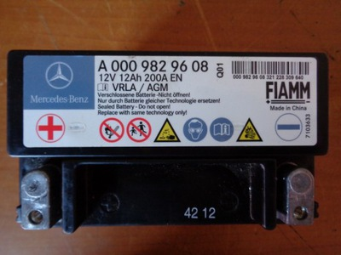

- Auxiliary located in trunk behind passenger side-panel.
- Primary in trunk below floor panel in middle at rear seat.
- Mercedes link to purchase: https://mercedespartscenter.com/parts/index.cfm?siteid=215720

