Opening Roof
- Switch on ignition and actuate Vario roof switch until Vario roof has reached intermediate position.
The illustration shows the Vario roof in the intermediate position (C-pillars are positioned at an angle of approx. 90°). The trunk lid is in the assembly position.

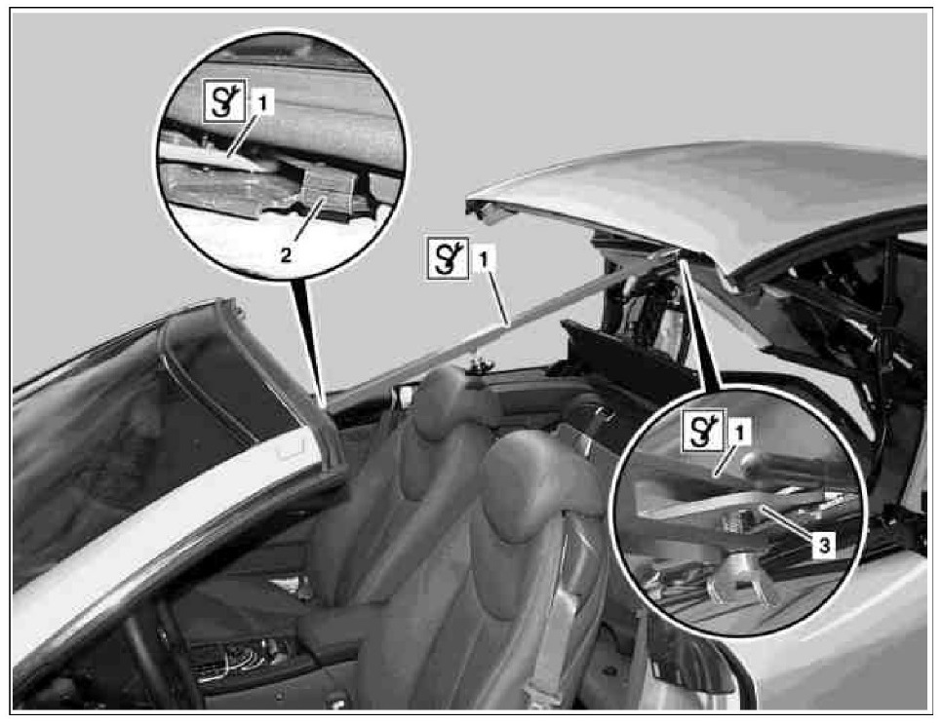
- Secure Vario roof intermediate position. For this purpose install support (1) on left mount for front catch (2) and left catch section on Vario roof front section (3).
The support (1) can be shortened, if required, and extended to secure the intermediate position of the Vario roof.

