01-21-2022, 05:40 PM
#6
CaliBenzDriver
MBWorld Fanatic!


Join Date: Apr 2019
Location: Silicon Valley
Posts: 3,248
Likes: 2,770
Received 2,017 Likes on 1,369 Posts
MY'14 W212 M276 @50kMi & HondAcura
killer surge courtesy of K57/K75 coils...

Quote:
Originally Posted by Frederick NL
Overheating and setting the car on fire, for one thing (several cases seen in the forums).
Any clue would be fantastic. Are you familiar with the functional description of the module (N82/1)?
Now I understand what can help you guys stop replacing this module... coil surge protection
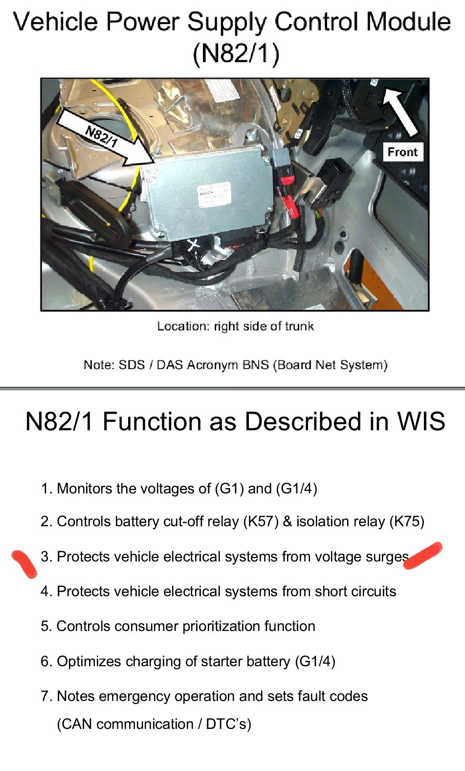
functionalities of "power supply controller'
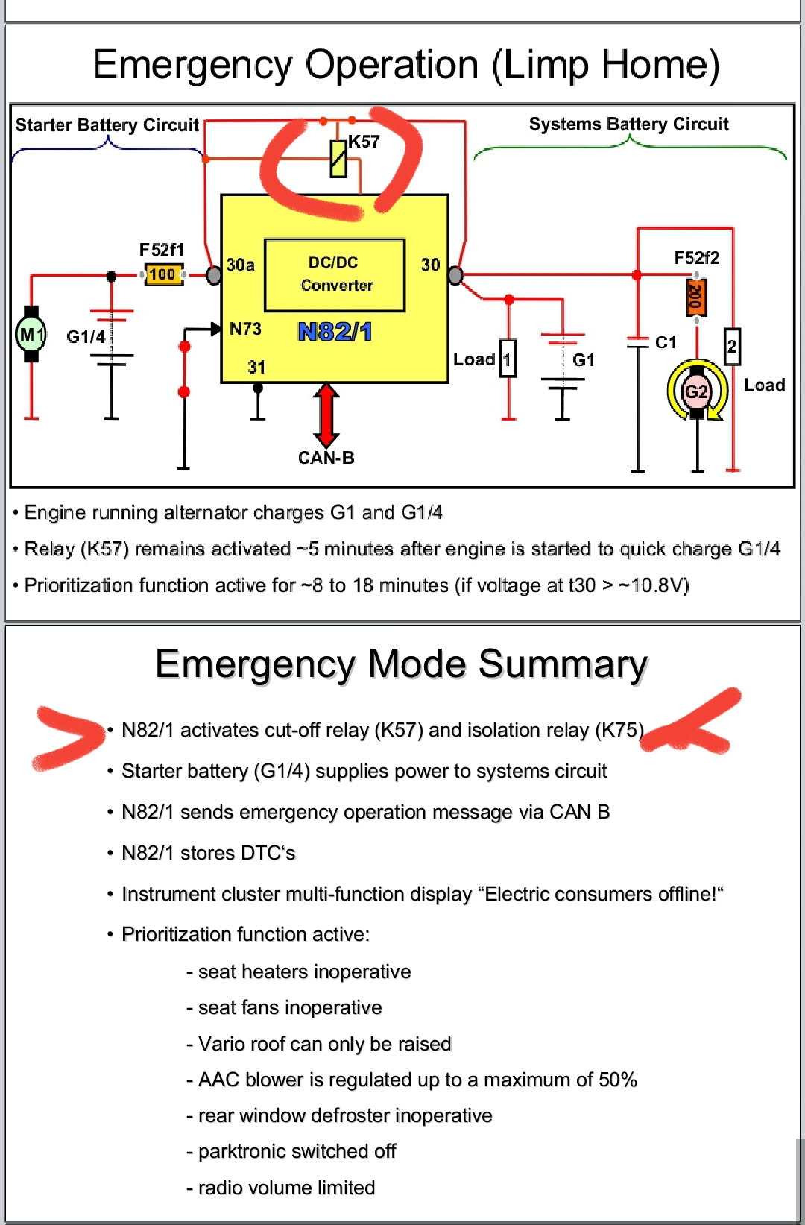
Emergency ... Relay actuation
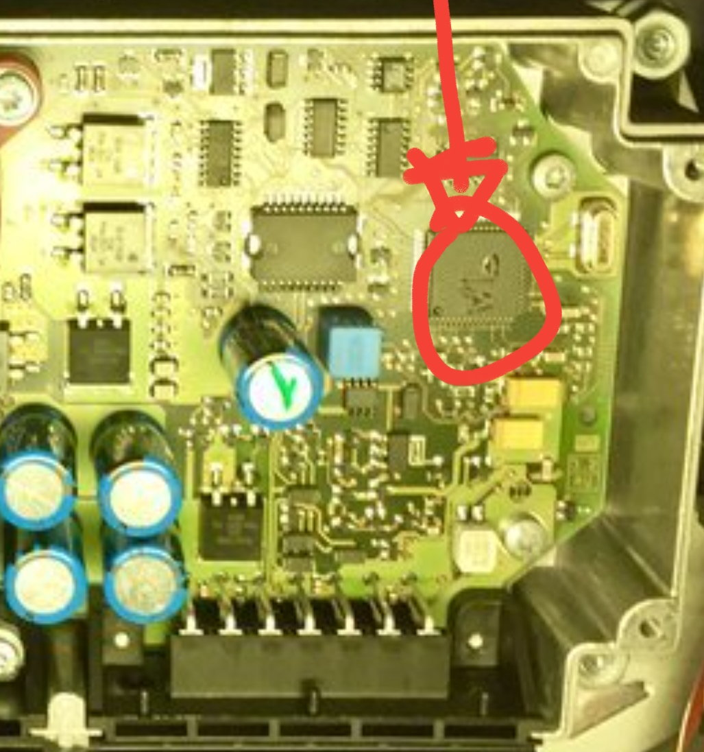
blown hole in CPU packaging!!!
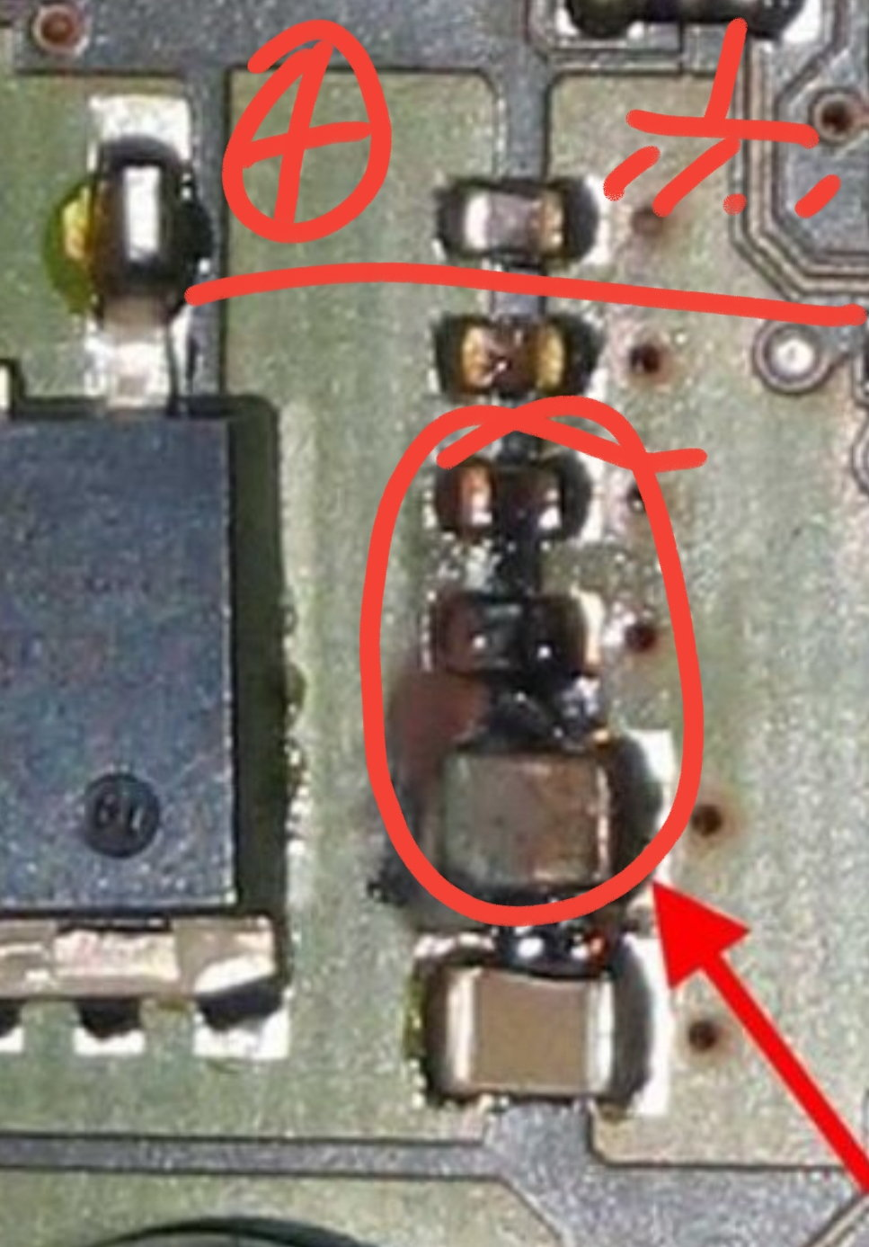
VCC/GND bleed resistor + ceramic caps... toasted
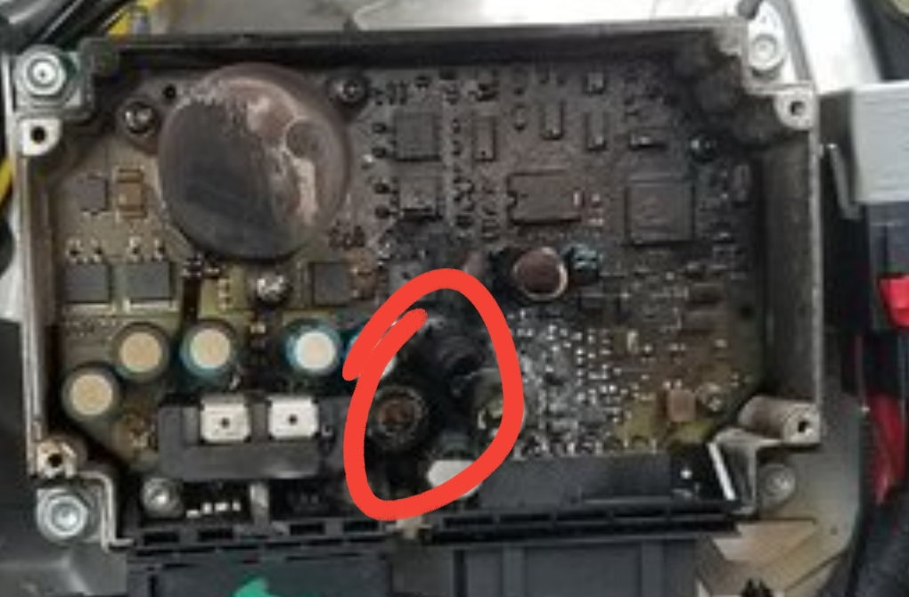
exploded power filtering capacitor
PROBLEM:
When I add up all the above info, I can say 99% chance this circuit gets destroyed by high voltage spikes, not by high currents.
Once critical parts are melted, they present a short circuit path... that's when high current can creates toasty fire conditions.
When you look around a bit for a "smokin' gun" that can create the perfect surge: two power relay coils turn up!
These coils get activated under rare conditions when the main battery voltage is in trouble (One more good reason not to let your battery get low ---> float it!!).
The pics above show how these surges cook everything all the way to the CPU itself. By the time a collection of passive parts are cooked, you can be sure the more fragile active silicon were wasted prior ---> scrap pile
SOLUTIONS:
If I was to prevent this failure, I would work on the 2x relay coil protection.
You know how an "spark plug ignition coil" works, right? Here the relay coil works the same way except we don't want the nasty high voltage spike from it! The energy created needs a place to drain into. Either a backwards diode or a resistor to protect the circuit board. This is called a snubber circuit, look it up.
Chances are the circuit designers already included some form of coil protection but for sure, it ain't good anymore! You got to work on this protection before your good board gets spiked. Have a look and let's see if it can be improved. Perhaps its a "MOV" varistor that gets wasted after couple shots...
Newer cars use a solide state MOSFET relays to do away with these nasty coils... However relays have been okay for the past 100 years when designed around properly.
​​​​​​How about using an automotive small cube type relay to control each big coil from a circuit away from this module feed.
Hope this helps ya
1- Cube relays in between:
Smaller coil, smaller inductance, less powerful spike energy... but still a high voltage surge that need to be dumped.
The smaller relay contacts will then be tasked with switching the K- Coils.
2- K relays:
These stay the same because they do a very special job at switching high battery Amps around. Any big relay will have a big coil and a powerful spike. So keep existing and work their problem.
3- (dV/dT) traveling surge:
​​​​​​The spike wave follows the wire its in. The work spike is used because it is super tall and super short. When you through your best shot at spike you have a chance, I mean use a combination of "best practice" to deal with spike because not I magic thing will make a coil spike disappear. You have to be smart with it.
We are dealing with K coils:
- Physically away from BCM
- Big diode ?
- MOV
- Parallel & serial resistor or RC network
- .....
Like a tsunami burst wave...:
Identify existing coil spike counter measure if any and fix them up to better eat the spike punch.
Spike energy needs to go somewhere, you just need to give it a path to get lost
yes, correct, everything is connected in one single 12 volt circuit but with many branches.
Coil spikes are made of high frequency oscillations. This energy does not travel too well in DC circuits. It looses momentum due to wiring impedence.
Practically...layered protection:
You use a long wire protected by a modest 5 to 10Amp fuse (high R) to feed the cube relay contact that command each K-coil. The cube coil power uses the line that was previously commanding each K-relay. By doing that we are inserting a serial resistance to feed each K-coils.
A ceramic capacitor connected near the coil would do well to clamp the spike by charging from it.
A reversed diode is also used frequently in parallel with relays.
The key is to eat the spike energy because you can not just "block it" (it's like stopping a freight train).
All this is nothing new, I am sure there are some excellent published solutions available.
In fact the BCM is built to eat over voltages.... may be it has a form of protection that needs rework

